**Global Sea Level Rise and Coastal Vulnerability Assessed via Inundation Maps**

Master Thesis in Geoinformatics Engineering

Author: **Sahar Gholami Bourani**

Advisor: **Maria Antonia Brovelli**

Co-advisor: **Jürgen Kusche**

Student ID: 10718755

Academic Year: 2023-24

# Abstract

Sea level rise, as a crucial aspect of climate change, has a significant impact on the coastal areas around the world. It has been threatening many lives, lands, ecosystems and infrastructures by the sea and depending on the future climate storylines, it will continue to rise with the same rate or accelerates to rise which consequently will impact severe effect on future costal area.

In this research, we assess the coastal vulnerability, assuming that the observed trend of sea level rise during 2005 to 2015 will continue to rise with the same rate until the end of the century. To accomplish this, we utilize GIS-based tools to simulate the coastal flood considering the current understanding of regionally differentiated relative sea-level rise. Analyzing the inundation maps enable us to visualize the potential impacts on coastal regions throughout the 21st century and assess the potential at-risk lands and populations. Our approach involves simulating future sea level heights by integrating data from various sources. We then use the Digital Elevation Model (DEM) to characterize the land surface, allowing us to produce detailed inundation maps.

For this study, we focus on a bounding box of the Baltic and North Sea coastal areas, that contains German coastal region. However, the data and methodology are globally applicable. The vulnerability assessment of the study area showcases different susceptibility of the Baltic and North Sea with respect to SLR due to different characteristics of the two seas. It is concluded that in total 1,942 km2 of the coastal region in the study area will be flooded due to sea level rise during 2020 to 2100, averaging 24.3 km2 per year. Additionally, it's projected that 153,116 individuals from the current inhabitants and 40,737 individuals of the projected population of the study area will be affected between 2020 and 2100, with an average of approximately 1,914 people per year.

**Key-words:**

Sea Level Rise, Coastal Vulnerability, Inundation Maps, Climate Change, GIS.

# Abstract in italiano

L’innalzamento del livello del mare, in quanto aspetto cruciale del cambiamento climatico, ha un impatto significativo sulle aree costiere di tutto il mondo. Ha minacciato molte vite, terre, ecosistemi e infrastrutture in riva al mare e, a seconda delle future trame climatiche, continuerà a crescere con lo stesso ritmo o accelererà la sua crescita, il che di conseguenza avrà gravi effetti sulla futura area costiera.

In questa ricerca, valutiamo la vulnerabilità costiera, assumendo che la tendenza osservata dell’innalzamento del livello del mare tra il 2005 e il 2015 continuerà ad aumentare con lo stesso ritmo fino alla fine del secolo. Per raggiungere questo obiettivo, utilizziamo strumenti basati su GIS per simulare l’inondazione costiera considerando l’attuale comprensione dell’innalzamento relativo del livello del mare differenziato a livello regionale. L’analisi delle mappe delle inondazioni ci consente di visualizzare i potenziali impatti sulle regioni costiere nel corso del 21° secolo e di valutare i territori e le popolazioni potenzialmente a rischio. Il nostro approccio prevede la simulazione delle future altezze del livello del mare integrando dati provenienti da varie fonti. Utilizziamo quindi il modello digitale di elevazione (DEM) per caratterizzare la superficie terrestre, consentendoci di produrre mappe dettagliate delle inondazioni.

Per questo studio, ci concentriamo su un riquadro di delimitazione delle aree costiere del Baltico e del Mare del Nord, che contiene la regione costiera tedesca. Tuttavia, i dati e la metodologia utilizzati sono applicabili a livello globale. La valutazione della vulnerabilità dell’area di studio mostra una diversa suscettibilità del Baltico e del Mare del Nord rispetto alla SLR a causa delle diverse caratteristiche dei due mari. Si conclude che in totale 1.942 km2 della regione costiera nell’area di studio saranno inondati a causa dell’innalzamento del livello del mare nel periodo 2020-2100, con una media di 24,3 km2 all’anno. Inoltre, si prevede che tra il 2020 e il 2100 saranno colpiti 153.116 individui degli attuali abitanti e 40.737 individui della popolazione prevista dell'area di studio, con una media di circa 1.914 persone all'anno.

**Parole chiave:**

Innalzamento del livello del mare, vulnerabilità costiera, mappe delle inondazioni, cambiamenti climatici, GIS.

# Contents

Abstract iii

Abstract in italiano iv

Contents v

Introduction 1

1 Research context 3

1.1. Research Problem and Conceptual Framework 3

1.1.1. Sea Level Rise Trend 3

1.1.2. Key Processes Driving Sea Level Change 5

1.1.3. Terminology and Key Processes in sea level rise 6

1.1.4. Global, regional and local sea level change 11

1.1.5. Sea Level Rise and Coastal area Vulnerability 14

1.2. Literature Review and State of the Art 15

1.2.1. Publication: papers 16

1.2.2. Assessment Reports in Sea Level Rise 16

1.2.3. Sea Level Rise Platforms 19

1.2.4. NOAA Sea Level Rise Viewer 25

1.3. Study Area 26

2 Data and Methodology 28

2.1. Workflow 28

2.2. Sea Level Change for the base year 29

2.3. Sea Level Rise Trend between 2005-01 to 2015-12 32

2.4. The Geoid data 34

2.5. Digital Elevation Model and Bedrock Elevation 35

2.5.1. Bedrock Elevation 35

2.5.2. Digital Elevation Model 36

2.6. Mean Sea Surface 37

2.7. Computation’s pre-requirements 39

3 Result 40

3.1. Simulation of Future Sea Level Height 40

3.2. Identifying Flood Plain 43

3.2.1. Analysis the inundated costal area 47

3.2.2. Vulnerable population 47

4 Conclusion, Limitation and Future Development 50

Bibliography 53

A. Appendix 65

List of Figures 66

List if Tables 69

Acknowledgments 73

# Introduction

The global mean sea level (GMSL) rose faster during the 20th century comparing previous centuries over the last 3000 years, with a 0.20 m rise over the 1901–2018. The acceleration of GMSL rise increased from last years of 1960s, with an average rate of 2.3 mm/yr over the period 1971 to 2018 which then increased to 3.7 mm/yr over the 2006 to 2018

Human actions mainly drive the increase in global sea levels since 1970, and this pattern is estimated to persist for centuries. Estimating future rises in sea levels poses a challenge due to uncertainties within climate models and the complex nature of coastal regions. Different climate models outline various scenarios for future climates, suggesting different rates of sea level rise under each scenario.

Relative to the period 1995–2014, GMSL will rise 0.18 m by 2050 and 0.38 m by 2100 under the most optimistic scenario. While the same statistics will increase to 0.23 m to 0.77 m under the most pessimistic scenario, for 2050 and 2100 respectively. These likely range projections do not include those ice-sheet-related processes that are characterized by deep uncertainty.

The impacts of climate change on coastlines regions will affect a signifant portion of the global population, economic activities, and infrastructure. Currently 23–37% of the global population live within 100 km of shorelines. However, coastal flood risk will rapidly increase during the next decades, possibly by 2–3 orders of magnitude by 2100.

This thesis expresses the coastal vulnerability by simulating global sea level height and future inundation maps. Therefore, the following chapters follow the workflow for the research purpose:

Chapter 1 establishes the research context for the thesis by exploring the trajectory of sea level rise, main concepts and contributors of sea level rise, emphasizing the urgent need to comprehend and address the impacts on coastal ecosystems and human settlements. In the same chapter, the research works and GIS platforms in sea level rise and coastal inundation visualization are surveyed. It ends with introducing the case study and its coastal vulnerability impacted by SLR.

Chapter 2 introduces the methodology, model for the flood simulation, and data to integrate the model. It contains data planning, pre-processing phases for each data, and computation phase to simulate the food plains for each year.

Chapter 3 summarizes the result simulation model for sea level height and flood plain. The vulnerability of the lands and population by the coastal flood is assessed as the result of the thesis. The extended programming code related to this chapter 2 and 3 is attached in Appendix.

Chapter 4 marks the limitation and suggests future development for the current thesis.

# Research context

## Research Problem and Conceptual Framework

### Sea Level Rise Trend

Sea level is rising globally. The value of global mean sea level (GMSL) was highest measured in 2021. GMSL rose faster during the 20th century comparing previous centries over the last 3000 years (Figure 1), with a 0.20 m rise over the period 1901–2018. The acceleration of GMSL rise increased from last years of 1960s, with an average rate of 2.3 mm/yr over the period 1971 to 2018 which then increased to 3.7 mm/yr over the 2006 to 2018 [1].

During early 1900s, sea level rise was mainly caused by natural phenomena, for instance glaciers responding to the warming in the Northern Hemisphere in the 1800s. Althogh, from 1970, human activities are the main reason of global average sea level rise. Regrettably, they will be the main reason for the next centries [2].

It is expected that sea level will rise between 10-25 cm by 2050. The thermal expansion of the water, and melting ice sheets and glaciers are considered to be the main causes of current sea level rise. It is noteworthy that sea levels in different areas can vary from the global average, with minimal changes in places that were once covered by glaciers and the most significant changes occurring in low-lying river delta regions [2].

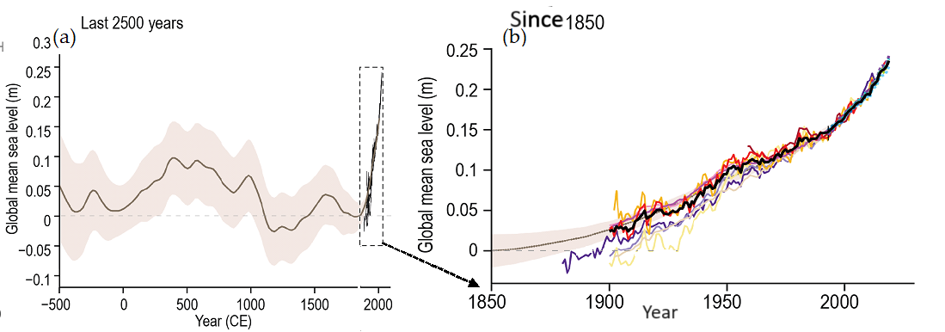

**Figure 1: Historical changes in global mean sea level. (a) Reconstructions for the last 2500 years based upon a range of proxy sources with direct instrumental records superposed since the late 19th century. (b) Tide-gauge and, more latterly, altimeter-based estimates since 1850** [2]

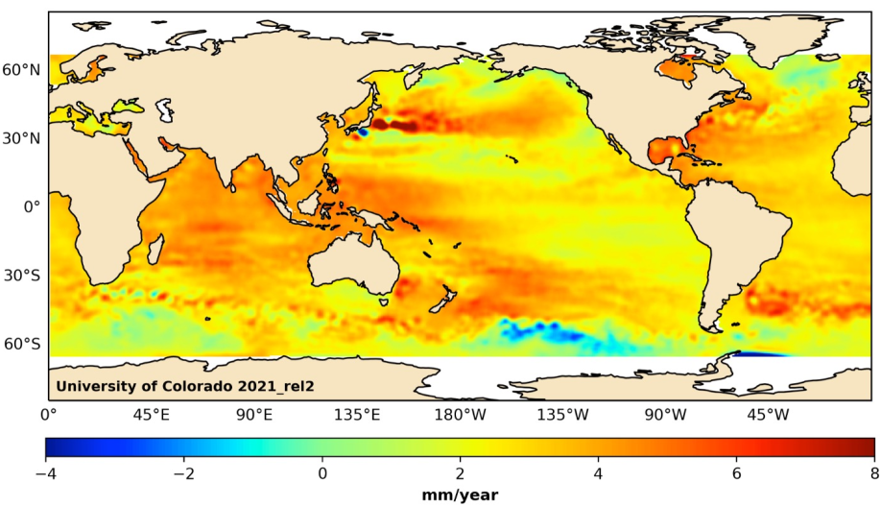**Figure 2: Sea surface Trend 1992-2021** [2]

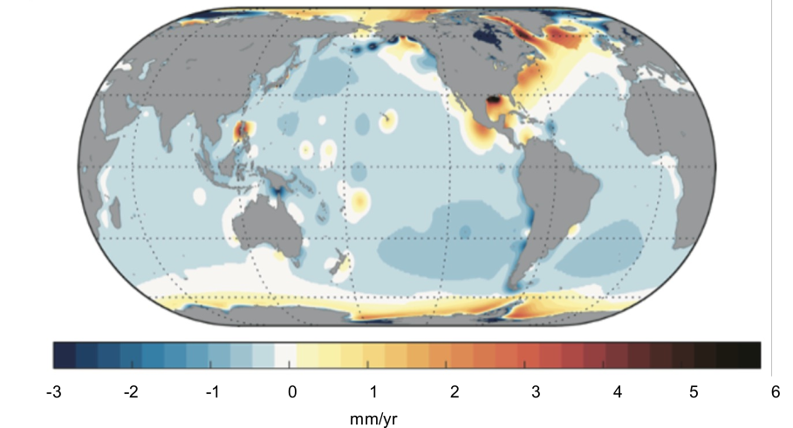Figure 3: Long-term land subsidence [2]

### Key Processes Driving Sea Level Change

The ocean and cryosphere, which includes frozen elements like sea ice, ice sheets, glaciers, permafrost, and snow, can interact by sharing heat and freshwater with the atmosphere and between themselves (Figure 4). As the climate warms, the global sea level rises due to the combined impacts of seawater thermal expansion and melting of the Earth's frozen components [2].

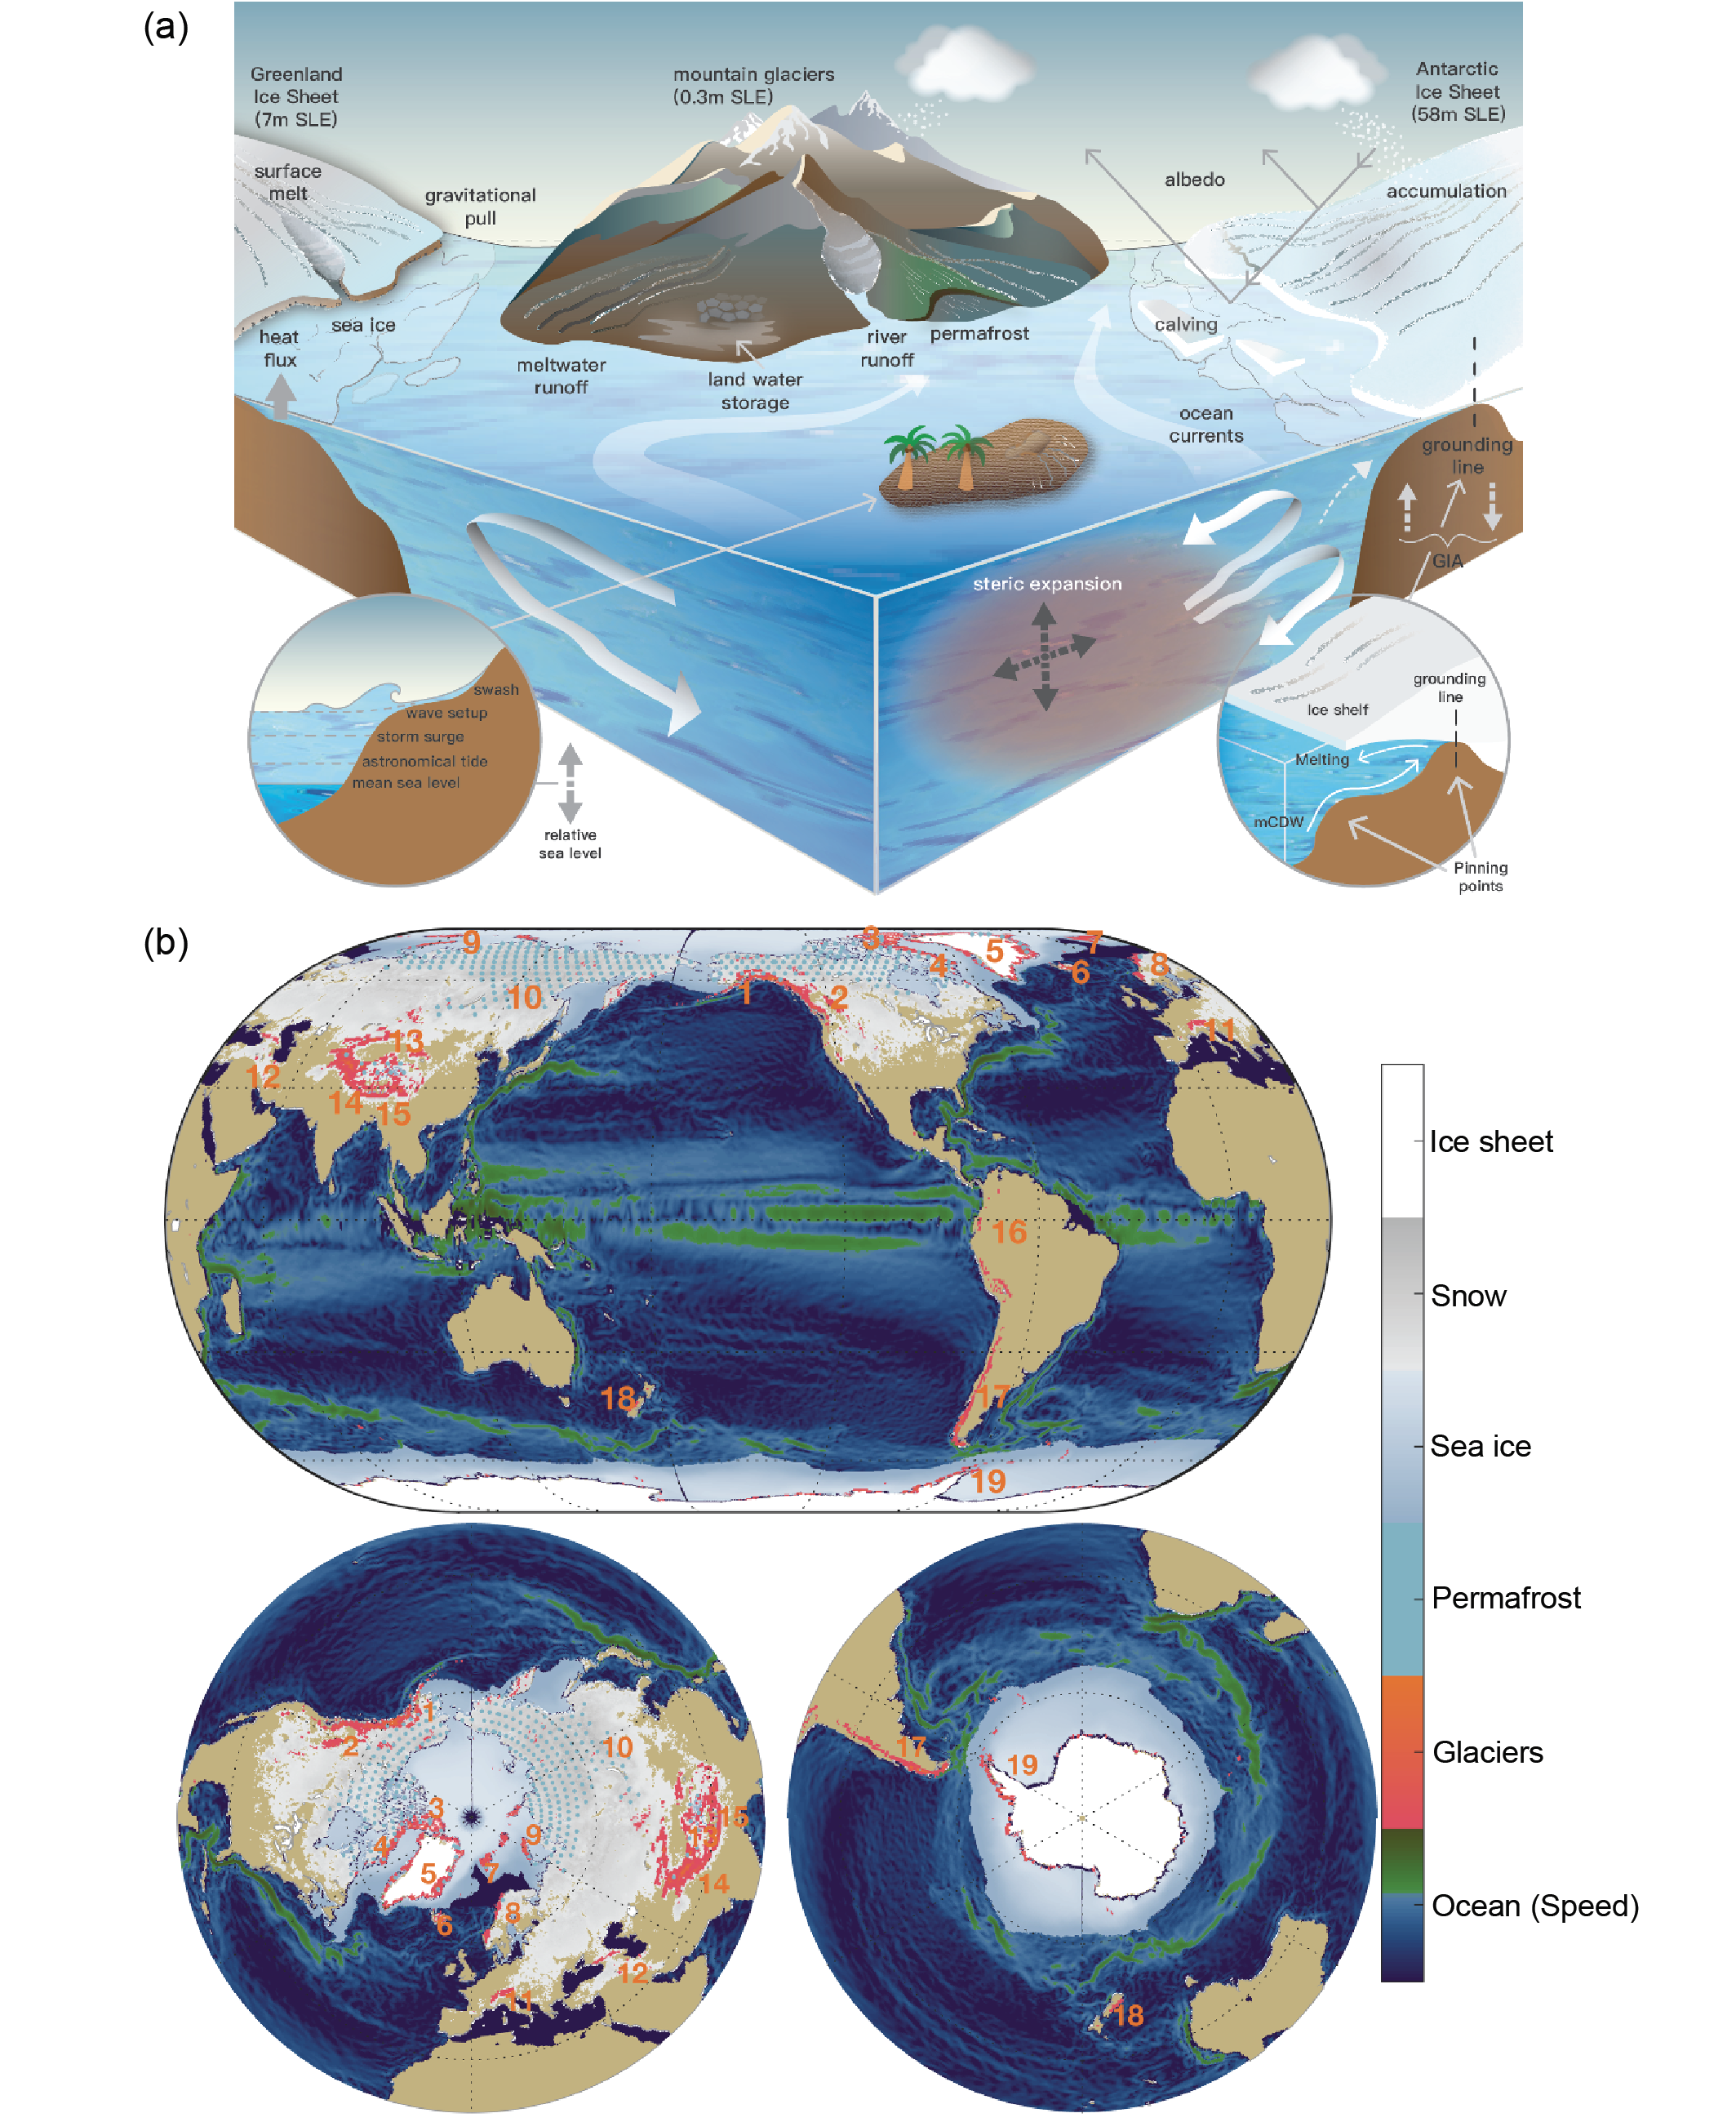Figure 4: The elements of the ocean, cryosphere, and sea level. Schematic of processes: mCDW=modified Circumpolar Deep Water, and GIA=Glacial Isostatic Adjustment. White arrows represent ocean circulation, while pinning points highlight locations where the grounding line is most secure, slowing down ice-sheet retreat [3]

Figure 5: Geographic distribution of ocean and cryosphere components (numbers indicate glacierized regions. Green ocean colors indicate larger surface current speed [3]

In pre-satellite era the sea level change had been evaluated by tide gauge (TG) data and in satellite era (from 1993) the altimetry data are also employed for sea level rise observation. Using a collection of TG reconstructions, it is evaluated that GMSL rose in average 1.38 mm/yr during 1901–1990 [4]. For the satellite era, the same value concluded equal to 3.25 mm/year and 3.69 mm/year for the period 1993–2018 and 2006–2018, respectively. [5].

### Terminology and Key Processes in sea level rise

**Geoid (G):** The geoid is a representation of the Earth's shape abstracted from its topographic features, and serving as an equipotential surface of the gravity field. It functions as an idealized mean sea level surface under static conditions, excluding factors like currents and air pressure changes [6]. The geoid concept involves maintaining a constant geopotential value so that to match the volume between the geoid and the sea floor with the time-mean volume of ocean water. While "z=0" denotes the geoid, "z>0" is above it, and "z<0" is below it. However, it is different from a surface of constant geodetic height "z' = z + G," where G is the geoid height above the reference ellipsoid (with G<0 where the geoid is below the ellipsoid) [7].

A **reference ellipsoid** is a conventional geometric shape that is used to define positions on the Earth in comparison to the solid Earth. It's an ellipsoidal surface which is defined to closely approximate the geoid (also not the same). The characteristics of a reference ellipsoid remain constant over time [7].

The **Ellipsoidal Height (h),** also known as geodetic height, is the distance from a point to the ellipsoid which is measured vertically along a line perpendicular to the ellipsoid. To locate a point (x) in 3D space (Figure 6) based on the reference ellipsoid, we draw a straight line from x to the ellipsoid's normal, intersecting at point r. The geodetic height of x above the ellipsoid is the distance from r to x along this line, positive outward [8].

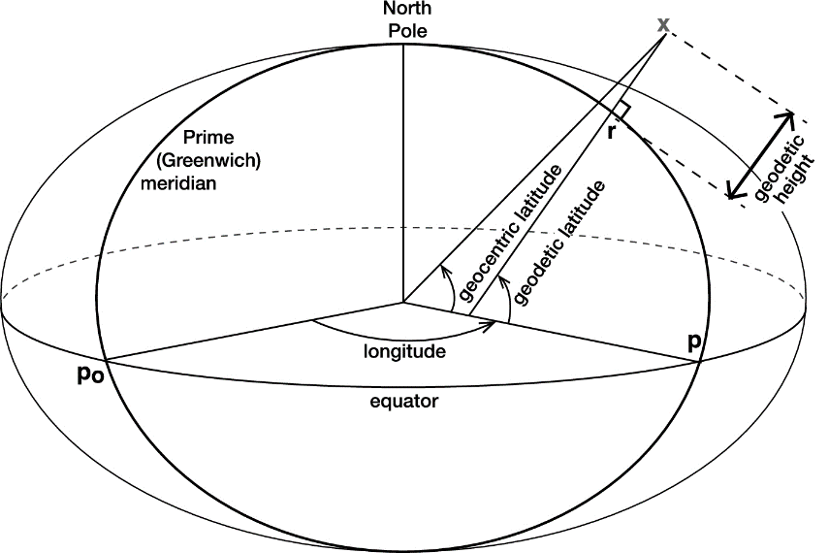

Figure 6: Geodetic Height [7].

Sea surface refers to the time-varying top boundary of the ocean. In this sense, sea-surface height (SSH) is the geodetic height of the sea surface relative to the reference ellipsoid [7].

Mean sea level (MSL) is the time-mean of the sea surface. MSL is sometimes called mean sea surface [2].

*“Sea floor: The lower boundary of the ocean, its interface with the solid Earth. The shape of the sea floor is sometimes called the bottom topography or the bathymetry. The level of the sea floor varies due to solid-Earth tides, accumulation of sediment (with eventual compaction) and vertical land movement on a range of timescales”* [7]*.*

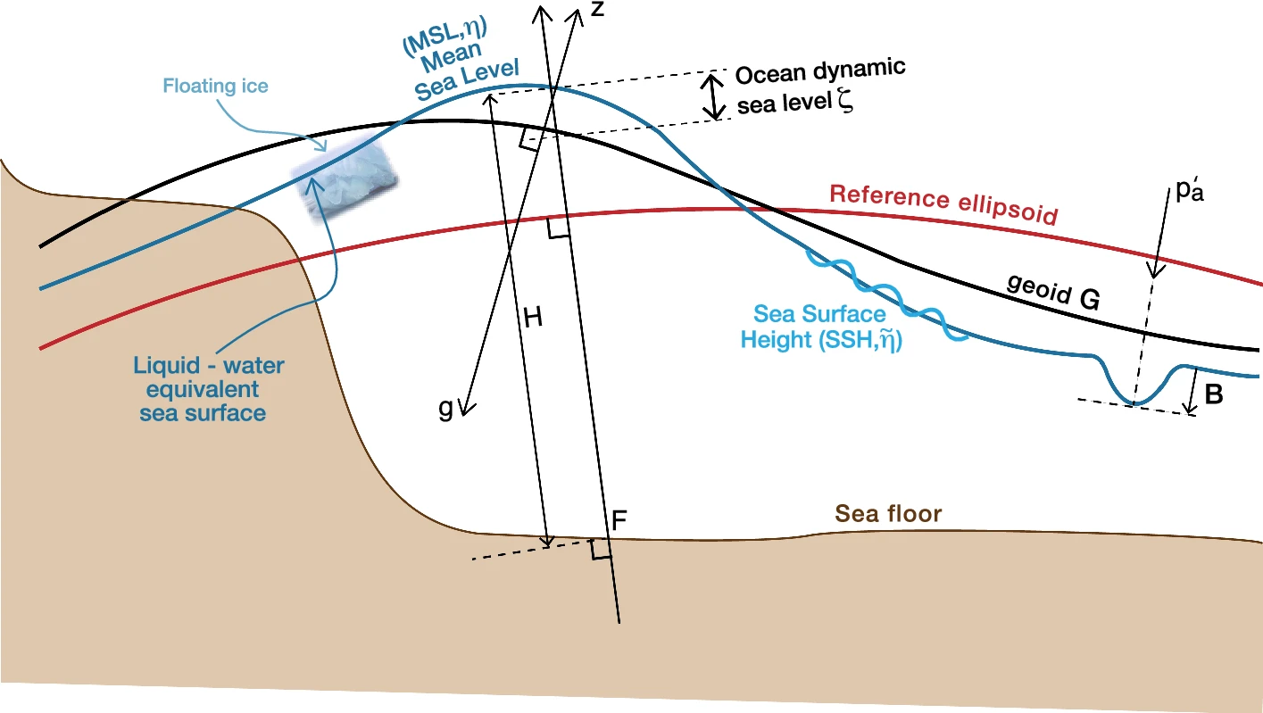

Figure 7: Relationship between surfaces relating to sea level [7]

**Inverse barometer** (IB): time-varying hyfrostatic depression in the sea surface due to change in the pressure of atmosphere.

***“Ocean dynamic sea-level change:*** *The change in time-mean ocean dynamic sea level , i.e., the change in IB-corrected mean sea level relative to the geoid”* [7]*.*

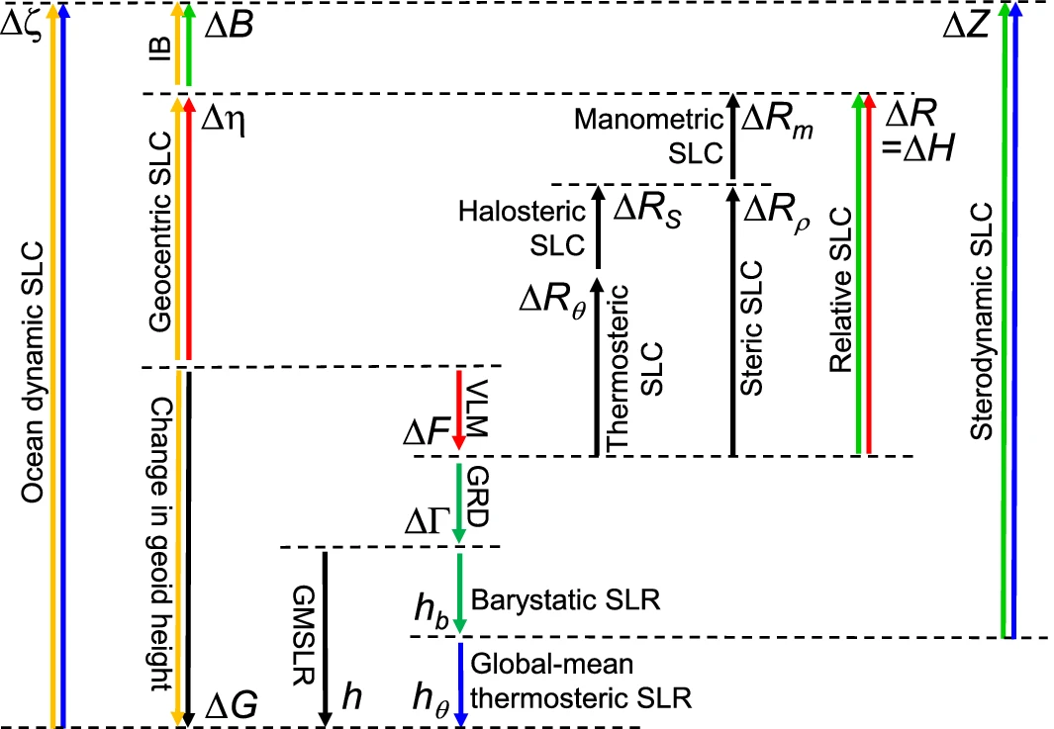

Figure 8: Relationships between quantities that determine changes in sea level [7]

**Vertical land movement (VLM):** The change in the height of the sea floor or the land surface. VLM can have various reasons, such as isostasy, elastic flexure of the lithosphere, earthquakes and volcanoes (due to tectonics) [7].

**Relative Sea Level change** is the change in local mean sea surface height relative to the sea floor. This value is usually measured by tide guages. On the other hand, **geocentric sea level change** is the change in local mean sea surface height relative the Earth reference frame, like altimetry sea level change.

**Uncertainty:** A state of incomplete knowledge that can result from a lack of information or from disagreement about what is known or even knowable [9]. Uncertainty has in close relation with confidence and likelihood. Uncertainties in projections are related to missing process knowledge, choice of model configurations, missing data, variables that have not been measured, erroneous data, internal variability (‘noise’); While uncertainties in not only contains all the parameters mentioned, but also includes the assumption on what is most likely [10].

**Confidence** is a qualitative measure of the validity of a finding. This concept is mostly used in climate modelling, therefore used in Intergovernmental Platform for Climate Change (IPCC) terminology. In order to evaluate the validity of finding, IPCC use some measures including type, amount, quality, and consistency of evidence. Generally, evidence is most robust when there are multiple, consistent independent lines of high-quality evidence. Then, the agreement over these measures defines the level of confidence. In such a way that the higher agreement with higher evidence, guarantee higher confidence scale (Figure 9) [11]. Ranges of confidence include “very low,” “low,” “medium,” “high,” and “very high.” Confidence and probability are different concepts [11]

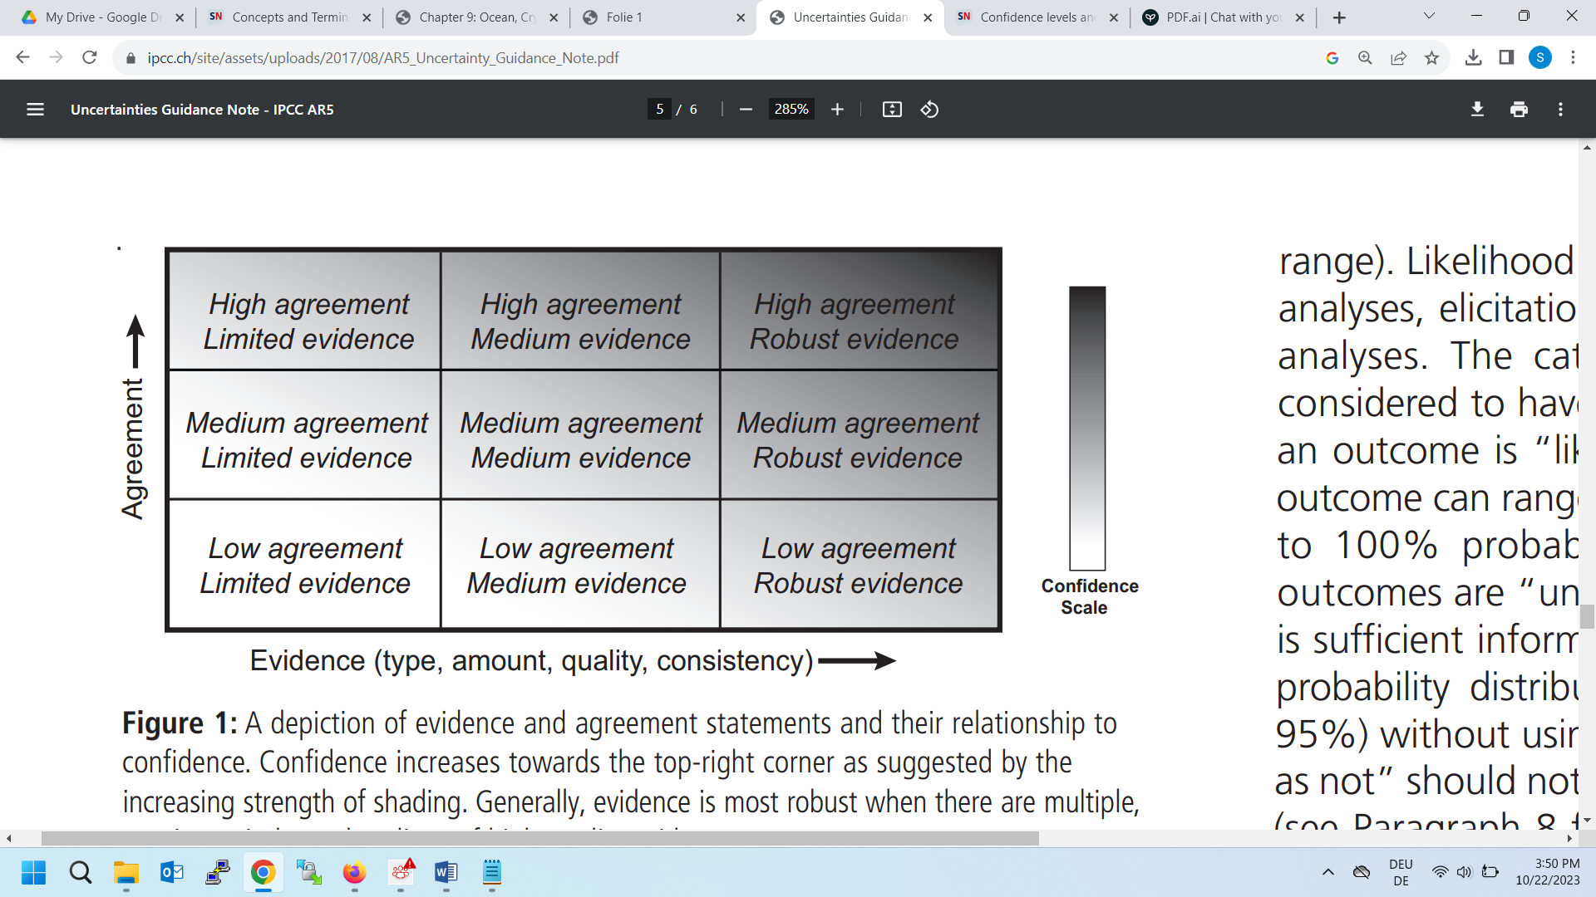

Figure 9: The relationship between evidence, agreement and confidence [11]

**Likelihood** presents precise language for quantified uncertainty (Table 1). A “likely” statement has greater 66% probability of occurance and an “unlikely” statement has less than 33% probability of occurance [11].

Table 1: IPCC likelihood scale [11]

|  |  |
| --- | --- |
| Term | Likelihood of the Outcome |
| Virtually certain | 99-100% probability |
| Very likely | 90-100% probability |
| Likely | 66-100% probability |
| About as likely as not | 33 to 66% probability |
| Unlikely | 0-33% probability |
| Very unlikely | 0-10% probability |
| Exceptionally unlikely | 0-1% probability |

**Shared Socioeconomic Pathways (SSPs)** are climate change scenarios of projected socioeconomic global changes up to 2100. They are used to derive greenhouse gas emissions scenarios with different climate policies [12]. This concept has been used in the IPCC Sixth Assessment Report (AR6) on climate change in 20214. The SSPs provide narratives describing alternative socio-economic developments. In terms of quantitative elements, they provide data accompanying the scenarios on national population, urbanization and GDP (per capita).

The scenarios in IPCC AR6 include:

* SSP1: Sustainability ("Taking the Green Road") – assumes rapid economic development and low population growth. Global Temperature is projected to increase 1.5 °C with more than 66% probability with respect to pre-industrial levels by 2100.
* SSP2: "Middle of the Road" scenario _ assumes that the current trend of socio-economic growth continues without significant effort to address the climate change. It includes both regional competitions and some cooperation, moderate population growth, and slower technological change. Under this scenario, the temperature is projected to increase 3°C above pre-industrial levels, with more than 50% probability by 2100.
* SSP3: Regional Rivalry ("A Rocky Road") _ This situation assumes a world that's split into regions competing heavily, with uneven economic growth and rapid population growth in some regions. It predicts slow technological progress and insufficient global action to address climate change. It is projected with more than 50% probability that the temprature will increase 4°C with respect to the pre-industrial levels by 2100.
* SSP5: Fossil-fueled Development ("Taking the Highway") emphasize overusing of fossil fuels, rapid population growth, and minimal effort for climate regulation and disjointed global collaboration. With more than 50% probability the temprature will increase more than 4 °C above pre-industrial levels by 2100 [13].

Following the different climate change scenarios, the sea level projection range will vary under different scenario, likelihood and uncertainties. GMSL will likely rise by 0.28-0.55m under a very low emissions scenario (SSP1-1.9), 0.44- 0.76 m under SSP2-45, 0.55 – 0.90 m under SSP3-70, and 0.63-1.02m under a very high emissions scenario (SSP5-8.5) by 2100, relative to the 1995-2014 average[1]

**Projections vs. predictions**

**Projections** encompass a range of likelihoods when describing potential future scenarios and the pathways leading to them. In a projection, a set of models is employed to provide a measure of confidence in the outcomes [10].

Scenarios, also known as "storylines," are coherent, internally consistent, and plausible depictions of potential future developments. Developing scenarios involves utilizing projections and incorporating additional information, such as baseline conditions. Scenarios are frequently used to capture the various levels of uncertainty inherent in projections, offering a broader view of the potential future. [10]

Climate **predictions** are estimates of future natural conditions, while climate projections are estimates of future climates under the assumptions of future human related activities such as socioeconomic and technical developments [14]

In contrast to a prediction, a projection specifically allows for significant changes in the set of "boundary conditions" that might influence the prediction, creating "if this, then that" types of statements. [15]

Predictions(forecasts) are projections that are designed to be most likely using a set of 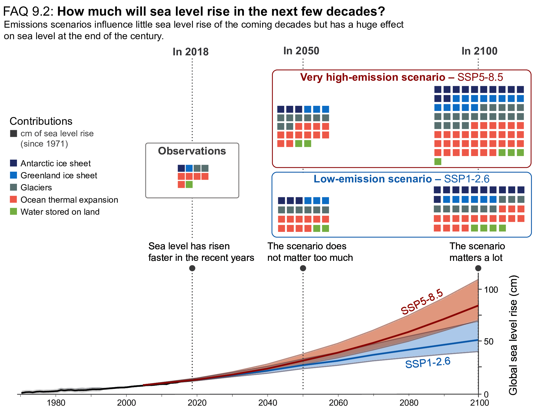models and observed data sets attaches confidence[10]

Figure 10: Observed and projected global mean sea level rise by IPCC WG1 and the contributions from its major constituents [16]

With medium confidence and relative to the period 1995-2014, the GMSL is expected to increase between 0.18 [0.15 to 0.23, likely range] meters (SSP1 1.9) and 0.23 [0.20 to 0.29, likely range] meters (SSP5 8.5) **by 2050**. While, **by 2100**, the rise is projected to be between 0.38 meters [0.28 to 0.55, likely range] (SSP1 1.9) and 0.77 [0.63 to 1.01, likely range] meters (SSP5 8.5). These likely range projections do not include those ice-sheet-related processes that are characterized by deep uncertainty1 [2].

### Global, regional and local sea level change

Although GMSL is an important climate measure, sea levels don't rise the same everywhere globally but they differ in various regions and locations. The drivers at **regional scale** (approximately by 100 km) can be counted as:

Change in ocean dynamics which is the result of ocean water density (temperature and salinity) change, or change in ocean-circulation that are caused by wind and density.

Mass distribution between land and ocean that leads to gravitational, rotational and deformational effects.

Natural or human-induced subsidence (through e.g., compaction of sedimentary layers due to groundwater extraction), glacial isostatic adjustment, and tectonics.

Losing the ice sheet mass, reduces its gravitational pull which consequently leads to fall in sea level in the area that are close to the ice sheet but rise in the sea level of the further area (eg. More than 2000 km away from the mass source) [17]. This effect is named as “fingerprint” and corresponds to the SLR in both Northern Hemisphere as the result of mass loss in Antarctic Ice Seet (AIS) or in Southern Hemisphere for the mass loss in Greenland Ice Sheet (GrLS) [17].

Figure 11 illustrates the processes that impact on sea level and their associated spatial and temporal scales.

Glacial Isostatic adjustment (GIA) refers to the Earth’s response to the changes between ice and water across its surface over a long time. When massive ice sheets melt or shift, it affects the shape and movement of the Earth's solid insides (mantle) over decades to thousands of years. This movement leads to changes in the Earth's shape and local movements, which can cause sea levels to change differently in various places.

Vertical land movement (VLM) can have value equal or higher than SLR. Therefore, it amplifys the local relative SLR. It can be the result of natural or human-induced, GIA and tectonics [17] [2].

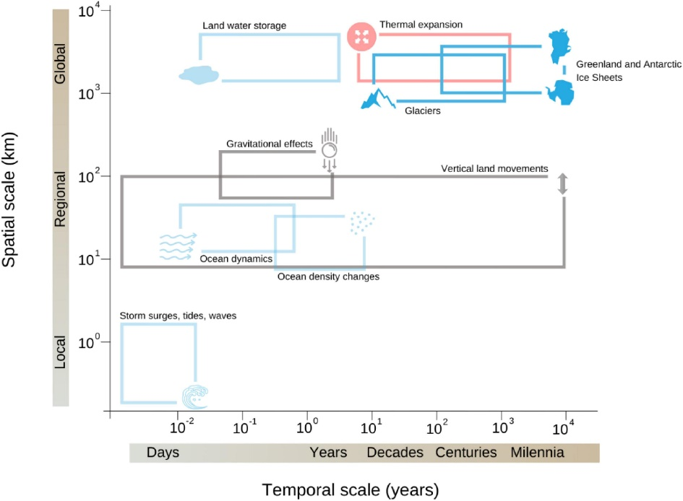

Figure 11: Illustration of the processes that contribute to sea level change with respect to their temporal and spatial scales [17].

At local scale (approximately by 10 km), SLR can be the result of process like ocean and coastal dynamics. Sea level extremes are an example in this scale. Tide and surge propagation, influenced by SLR and human modifications, can enhance extreme events beyond SLR alone. Coastal climate services must offer local sea-level forecasts incorporating the detailed analysis of all relevant factors. Relying only on global average projections could significantly misguide adaptation efforts, potentially resulting in maladaptation. While the extreme phenomena usually happen quickly (hours to days) and affect only specific regions along the coast, their impacts become more significant due to the gradual rise in sea levels over the long term [17].

As shown in Figure 11, global sea level rise is mainly derived by water thermal expansion, mething of glaciers, AIS and GrIS, and Land-Water storage [17]. GMSL change is interpreted as the change in volume of the ocean divided by the surface of ocean. It is the sum of changes in ocean density and changes in the ocean mass as a result of changes in the cryosphere or land-water storage [7].

Steric sea level change occurs because of changes in ocean density and includes 'thermosteric sea level change' from temperature shifts and 'halosteric sea level change' from salinity variations. 'Thermosteric sea level change' (also known as 'thermal expansion') is due to changes in ocean temperature Higher temperature lowers density and increases volume. 'Halosteric sea level change' is caused by variations in salinity, where higher salinity increases density and decreases volume [7].

The Greenland and Antarctic ice sheets are the largest reservoirs of frozen freshwater and therefore potentially the largest contributors to sea level rise. Antarctic ice is 90 percent of all the world's ice and 70 percent of all the world's fresh water [18]. Marine Ice Sheet Instability (MISI) and Marine Ice Cliff Instability (MICI) and basal sliding control the final contribution of the Antarctic ice sheet. In Greenland the most important processes are albedo, ocean forcing and atmospheric circulation changes. These three processes impact the surface mass balance (SMB) together controlling the SLR. Imbalance between mass gain and mass loss processed in Glaciers leads to sea level change (Figure 12) [19]. It is noteworthy to say that changes in temperature (ΔT) and precipitation (ΔP) will effect on SMB.

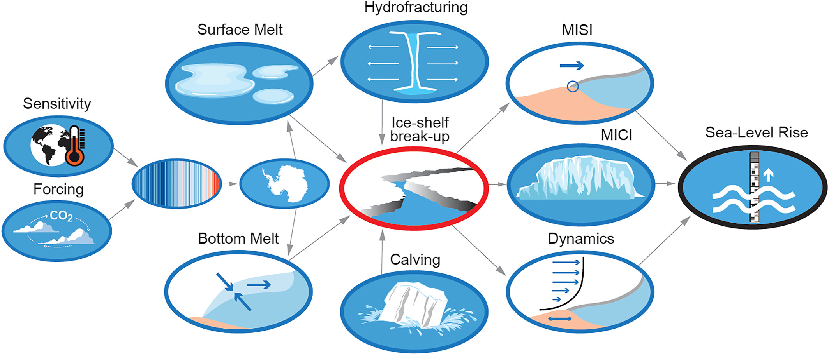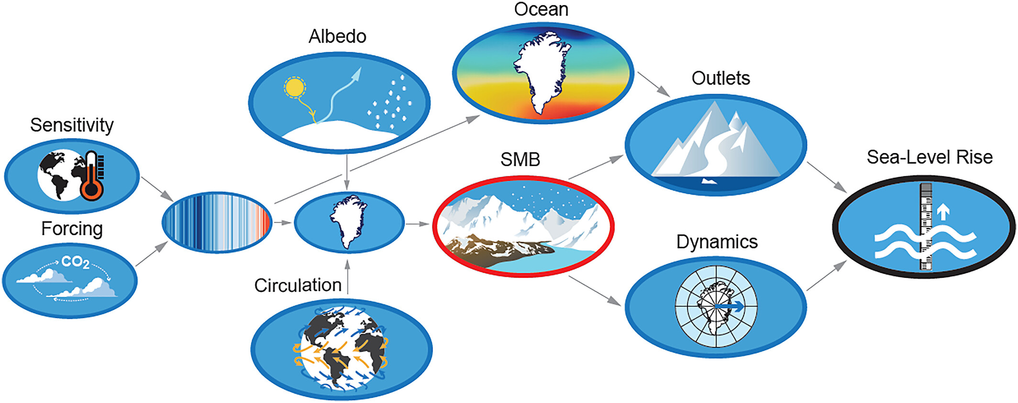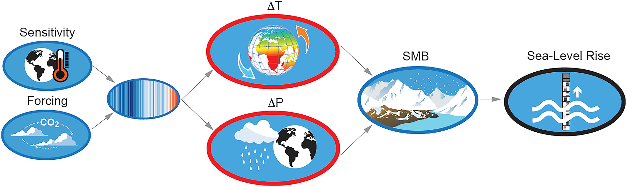

Antarctic

Greenland

Glaciers

Figure 12: relation between processes leading to sea SLR in Antarctica, Greenland and glacier [19]

### Sea Level Rise and Coastal area Vulnerability

Cities and settlements by the sea are dramatically facing the immediate impacts of climate change. Frequent and intense coastal flooding, loss of coastal ecosystem, submergence of the land by higher mean sea level are some climates induces risks that threatened coastal area. Unless implementing effective adaptation and mitigation strategies, the coastal flood risk will sharply increase, by 2-3 orders of magnitude by 2100. These hazards will impact the lives and socioeconomic systems in the coastal area. In 2020, about 11% of the world's population, which is 896 million people, lived in low-elevation coastal zones. These are coastal areas below 10 meters above sea level that are connected to the sea. This number is expected to potentially exceed 1 billion by 2050. Financially, USD 6,500–11,000 billion of infrastructural and economic assets are also exposed in the 1-in-100-year floodplain for coastal areas. Therefore, climate change impacts on coastal area affect a significant part of the world's people, economy, and essential infrastructure, either directly or indirectly [4].

## Literature Review and State of the Art

Regarding the publication papers on the research area of sea level rise and coastal vulnerability the results of Sarkar et al., study reveal that, on average, all criteria showed an increasing trend over the years (Figure 13); thus, revealing the 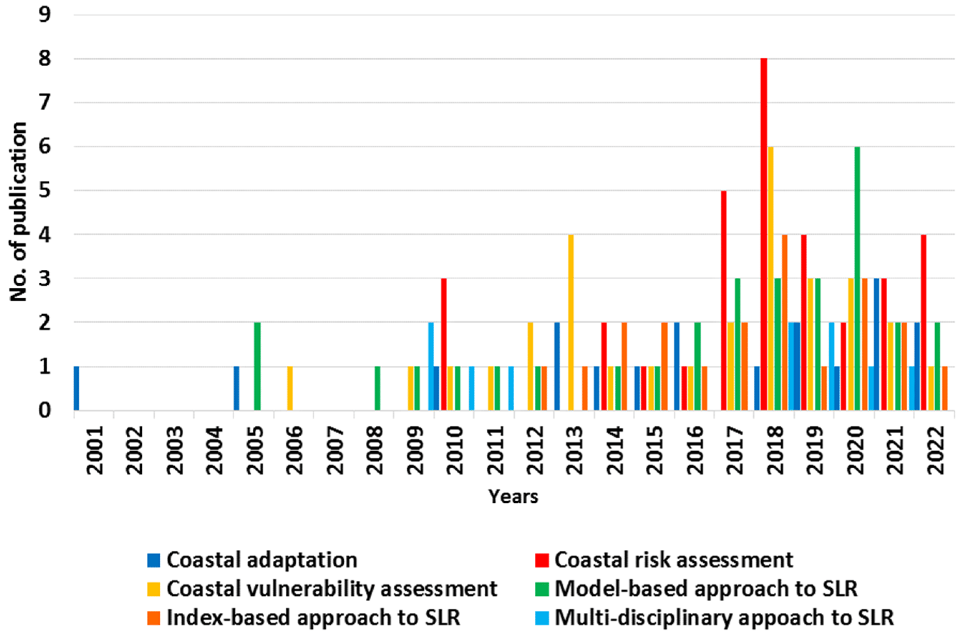increasing interest on climate-related coastal risk assessment and associated issues [20].

Figure 13: Trend of publications over the years focusing on various approach-based criteria [20]

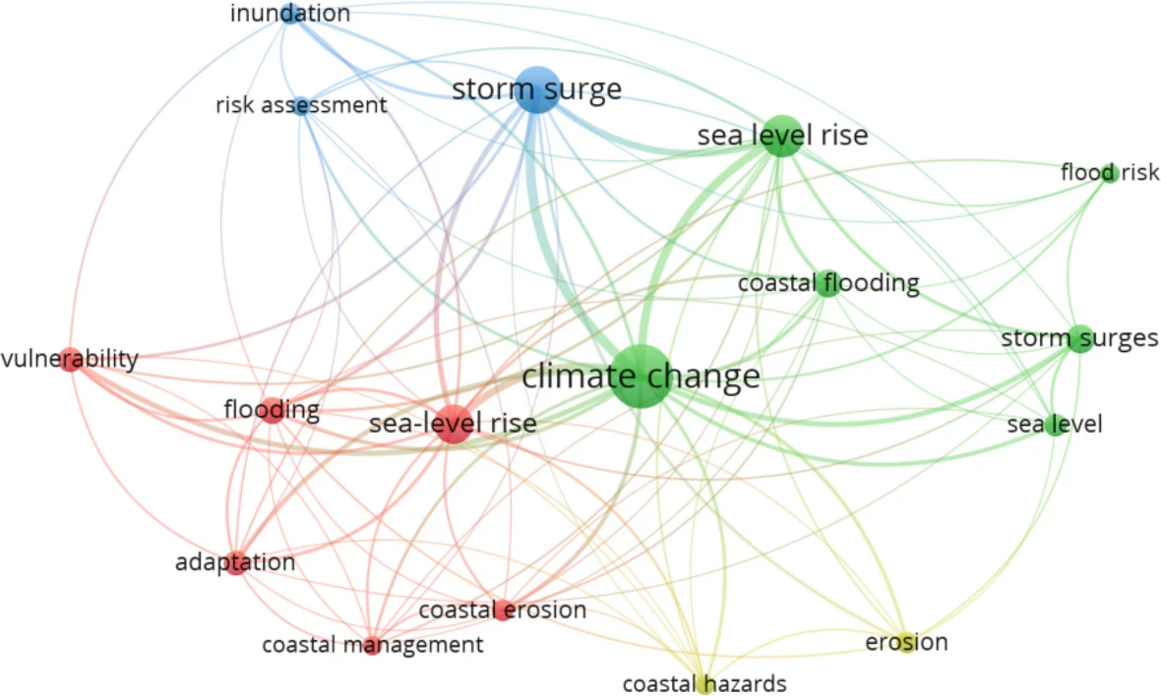

Figure 14: Keywords co-occurrence network based on incidences of keywords in [sea level rise] papers [21]54

### Publication: papers

Even though various research papers have been carried out in the area of sea level and costal vulnerability, only few of them developed or used GIS tools in their methodology.

Hadipour et al. [22] use a GIS-based spatial multi-criteria decision analysis approach to access coastal flooding risk. They consider two climate change scenarios, RCP 2.6 and RCP 8.5, and coastal flooding factors and develop a semiquantitative method. They produce inundation maps and evaluate the social vulnerability based on indexes define in the model.

Li et al. [23] propose GIS-based methods to assess and visualize the global impacts of potential inundation using the available global datasets. After recognition of susceptible areas, they estimate the size, population and land-cover types of the susceptible areas. However, it does not consider the influence of the current sea level on local flood levels and the impact of coastal flood protection.

For assessing the costs of sea-level rise and extreme flooding at the local level, Lichte et al. [24] utilize a GIS-based approach that categorizes low-lying raster cells in a DEM as floodplains. However, the analysis overlooks regional sea-level rise scenarios and does not account for uncertainties or local water levels.

Suwanno et al. [24] identify and analyze the suitable evacuation areas and routes in flood-prone zones using GIS-based tools. They use GIS-based methodologies and integrates spatial data sets and considers factors to evaluate flood risks and planning evacuation strategies. However, the study is constrained to the case study, also does not consider uncertainity in the asessment.

Bamber et al. [25] and Chu-Agor et al. [26] address modeling uncertainties of sea level rise in their research. Bamber et al. use structured expert judgements for uncertainty modelling. According to the expert group, the uncertainties have increased due to the growing knowledge about the involvement of inland ice. While Chu-Agor et al. use uncertainty analysis to simulate wetland transformation and coastline changes.

Schuldt et al. [27] investigate the simulation and visualization of regional sea-level rise using GIS in North Germany coastal area. The study utilize DEM, current sea level measurements, vertical land movement data, and regional sea surface elevation projections for 2100. Two climate scenarios from IPCC forecasts were considered. The research results in static maps and estimations of the affected lands and population due to potential flooding. However, the vulnerability assessment is performed for the current population and future growth of population is not applied in the analysis.

### Assessment Reports in Sea Level Rise

The Intergovernmental Panel on Climate Change (IPCC) began assessing the potential impacts of climate change on sea level rise in its First Assessment Report (FAR), which was published in 1990. In this report, the IPCC recognized the importance of sea level rise as a potential consequence of global warming due to the thermal expansion of seawater and the melting of glaciers and ice sheets.

The specific projections and assessments of sea level rise have evolved and become more refined in subsequent IPCC assessment reports (second to sixth assessment report and the special report on the oceans and cryosphere). It's important to note that the IPCC continues to release periodic assessment reports. At the time of writing this thesis, the latest AR of IPCC is associated to Working Group I (WG1) contribution to the Sixth Assessment Report (AR6), climate change 2021, The physical science basis, which was released on 9 August 2021. It provides updated scientific understanding and projections of sea level rise based on the latest available data and modeling at the time.

IPCC assessment reports were the main global data sources used in most of the considered papers [in coastal vulnerability and sea level rise] (Figure 15). They were followed by the NASA [28] and Copernicus data platforms [29] [30]. IPCC [31] is considered a highly favored tool for conducting scientific coastal research since it provides regular assessments on climate change, its impacts and related risks, and options for adaptation and mitigation [20].

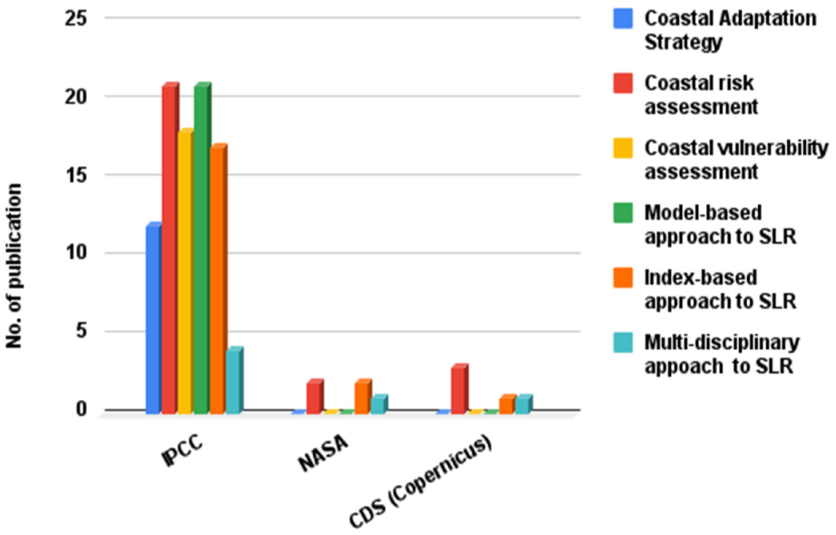

Figure 15: Comparison of relevant data platforms with respect to the approach-based criteria.[20]

#### SROCC

The Special Report on the Ocean and Cryosphere in a Changing Climate (SROCC), Chapter 4, focuses on Sea Level Rise (SLR) and its implications for low-lying areas. Oppenheimer et al. [4] analyze past and future contributions to global and regional sea level changes, as well as associated risks and response options. They highlight anthropogenic factors, including demographic trends and subsidence, as significant contributors to the vulnerability of coastal communities to SLR and extreme sea level events. These factors have also impacted freshwater and sediment availability in coastal deltas. Coastal ecosystems are already affected by SLR and human activities.

The study predicts that historically rare extreme sea level events will become common by 2100 due to projected global mean sea level rise (GMSL). Low-lying cities and islands will experience such events annually by 2050. Non-climatic anthropogenic drivers will further increase vulnerability without significant adaptation efforts. The report emphasizes the need for SLR responses, which encompass legislation, plans, and actions to reduce risk and enhance resilience. These responses involve protecting, accommodating, retreating, advancing, and ecosystem-based adaptation (EbA). However, identifying the most suitable response is complex and faces governance challenges.

The research evaluates different response types in terms of effectiveness, costs, benefits, drawbacks, and governance challenges. It identifies overarching governance challenges related to SLR's long-term commitment and uncertainty, as well as contested choices. Approaches and tools for planning, public participation, conflict resolution, and decision analysis are assessed to address these challenges.

Lastly, the report reviews enablers and lessons from practical SLR response implementations and emphasizes the importance of climate-resilient development pathways.

#### Cross-Chapter Paper 2: Cities and Settlements by the Sea

Glavovic et al. [4] in their study extends SROCC which focused on SLR. They explore a range of adaptation interventions, encompassing psychosocial, economic, physical, technical, and natural dimensions. These strategies for coastal C&S are typically categorized into protect, accommodate, advance, and retreat. While past adaptations to SLR indicate feasibility, future options are influenced by projected socioeconomic conditions and SLR rates. Glavovic et al., highlight a shift towards proactive and adaptive solutions, emphasizing the importance of an adaptation-pathways approach to improve climate risk management. The effectiveness and feasibility of these strategies are contingent on physical features, soft adaptation measures, and various socio-cultural, political, and institutional factors, ultimately shaping the solution space for mitigating risks through governance interventions and financial resources. However, rapid population growth and climate-driven impacts pose increased risks, particularly for smaller islands and poorer coastal communities.

The authors summarize key insights into enabling conditions and lessons learned for climate-resilient development in coastal communities and settlements. They highlight critical factors in three main areas: enabling behavioral change, finance, and governance.

Firstly, enabling behavioral change is essential, involving incentives like economic, informational, sociocultural, and psychological motivators. Public attitudes, climate information integration, self-efficacy, and trust in adaptation measures are all influential, necessitating supportive policies and financial provisions. Secondly, financial constraints pose a significant challenge for coastal adaptation, with varying funding sources and uncertainty regarding long-term sustainability. International donor aid's inconsistency and short-term nature impact long-term efforts, emphasizing the growing recognition of the importance of private finance. Lastly, governance plays a critical role, facing challenges from both climatic and non-climatic factors. Inclusive decision-making arrangements engaging diverse stakeholders and respecting indigenous and local knowledge are vital, while the law, although essential for regulating exposure and securing rights, can also be a barrier [32].

#### IPCC AR6 WG1 chapter 9

Working Group 1 (WG1) IPCC in Sixth Assessment Report (AR6) in chapter 9 (Ocean, Cryosphere and Sea Level Change) presents an evaluation of past and projected changes in the ocean, cryosphere, and sea level through paleoreconstructions, observations, and model simulations. It builds upon previous assessments, integrating findings from the IPCC AR5), the Special Report on Global Warming of 1.5°C (SR1.5), and Special Report on Ocean and Cryosphere in a Changing Climate (SROCC). The report offers insights into past changes, processes, and budgets for the last century, and use a range of models for better accurate projections and uncertainty estimations [2].

In the sub-chapter of sea level change in the same chapter, WG1 projects the sea level change for the century. They discuss the global and regional sea level change in pre-satellite and satelite er, global energy invetory and sea level budget, assess the observed contributions to GMSL change, paleo context of global and regional sea level change. Lastly, this sub-chapter results in the projection of the future sea level change. This projection has been performed for global and regional sea level change and for each contributor of SLR- and the total combination. This research also considers all five five socio-economic emission scenarios (SSP) and the uncertainty in their result dataset. Part of the complex dataset of IPCC is employed as an input in current research work.

### Sea Level Rise Platforms

#### IPCC AR6 WG1 Interactive Atlas

IPCC Interactive Atlas (IA) is a novel tool for flexible spatial and temporal analyses of much of the observed and projected climate change information underpinning the WG1 AR6 including regional synthesis for Climatic Impact-Drivers. [33] This is done by focusing on key atmospheric and oceanic variables (including sea level rise) adopting the methodological recommendations to navigate by global and regional information of future projections. The information is provided using a number of standard (such as maps, time series, scatter plots, tables) and modern (such as stripes) visuals suitable to communicate the information serving different purposes.

In particular for sea level rise variable, IA provides only CMIP6 projection model, for near, medium and long-term projection and in annual temporal resolution for the baseline 1995 to 2014 and under all emission scenarios.

The regional information component allows for flexible analysis of past and projected changes for over 25 variables and derived indices calculated from key climate datasets supporting the assessment done in the Chapters. The regional synthesis component provides flexible analysis of synthesis assessments over a new set of sub-continental reference regions supporting the Technical Summary and Summary for Policymakers. There are Jupyter Notebooks and many other resources in the Github repository of IPCC Atlas [34].

In the context of sea level rise, since IA illustrates the result of projected SLR by IPCC AR6, it considers climate change scenarios and the effect of all SLR contributors, including AIS, GIS, glaciers, vertical land motion, ocean dynamics, land water storage. However, this platform does not visualize the future flood maps caused by SLR.

Figure 16: IPCC Inteactive Atlas-Regional information – selected sample: sea level rise projection for western and central Europe under scenario SSP5-8.5 for the long-term period (2081-2100) [35]

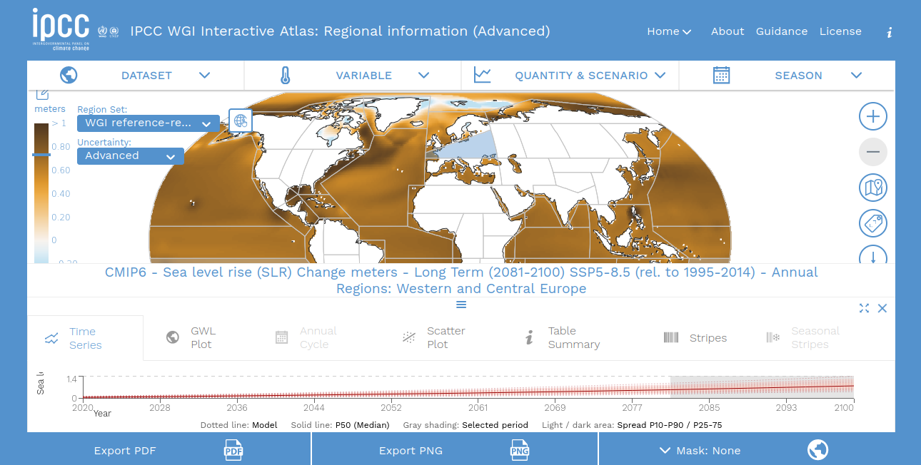

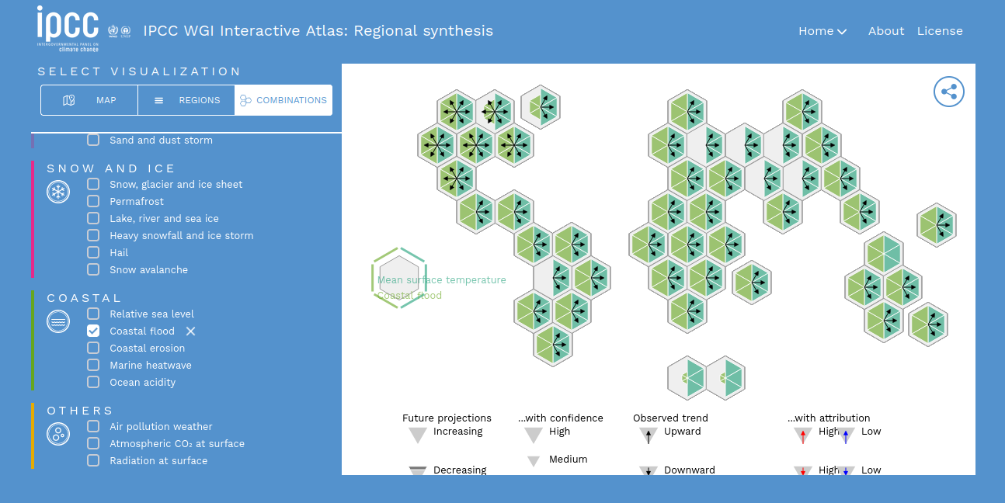Figure 17: IPCC Interactive Atlas-Regional synthesis – coastal flood [36]

Specific data about various areas through time series, annual cycle visuals, and scatter plots are provided (e.g. temperature versus precipitation), tabular summaries and stripe plots, combining a number of standard and modern visuals communicating the information serving different purposes.

The NASA has also developed user-friendly tools for providing easy to access sea-level information. The NASA Sea Level Change Portal [37] is designed as a "one-stop" source for current sea level change information, including interactive tools for accessing and viewing regional data, a virtual dashboard of sea level indicators, and ongoing updates through a suite of editorial products that include content articles, graphics, videos, and animations [38].

This platform provides various climate and analysis tools including:

#### NASA IPCC AR6 Sea Level Projection Tool

This Tool allows users to visualize and download the sea level projection data from the IPCC 6th Assessment Report (AR6). The goal of this tool is to provide easy and improved access and visualization to the consensus projections found in the report. The tool allows users to view both global and regional sea level projections from 2020 to 2150, along with how these projections differ depending on future scenario. Users can click on a point anywhere in the ocean to obtain the IPCC projection of sea level for that individual location. The contributions of different physical processes to future sea-level rise are also provided, indicating which processes will be the dominant drivers of future sea level for a given location. Finally, users can download the sea level projection data from the IPCC 6th AR6 in multiple formats. The projections shown in the tool are consistent with those in the IPCC 6th Assessment Report and information in the tool will be linked directly to the report when available.

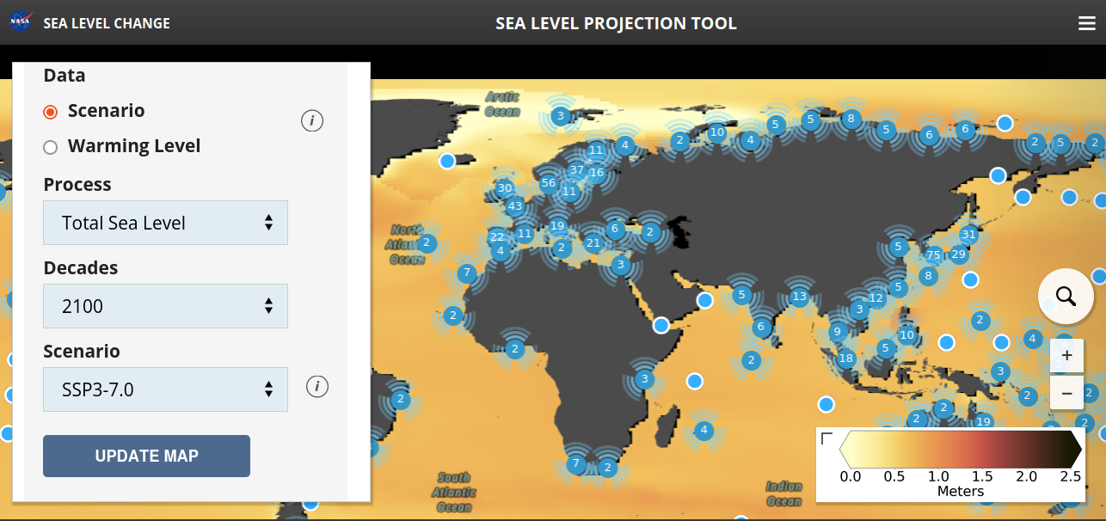Figure 18: NASA IPCC AR6 Sea Level Projection Too [39]

Like ATLAS, NASA IPCC SL platform visualizes only the SLR under difference scenarios and considers all SLR contributors in IPCC report, but it does not illustrate flood maps that SLR triggers.

#### NASA Interagency Sea Level Rise Scenario Tool

The sea level scenarios and information contained in this tool originate from a 2022 technical report produced by the Sea Level Rise and Coastal Flood Hazard Scenarios and Tools Interagency Task Force. This report provides the most up-to-date sea level rise scenarios, available for all U.S. states and territories, out to the year 2150. Unlike the IPCC, the focus of the report and this tool is the coastal extent of the United States. The set of global mean sea level rise scenarios are updated and downscaled for U.S from IPCC AR6. Similar to the previous platforms, it considers climate change scenarios and all SLR contributors but flood Analysis tool is implemented in a separated platform.

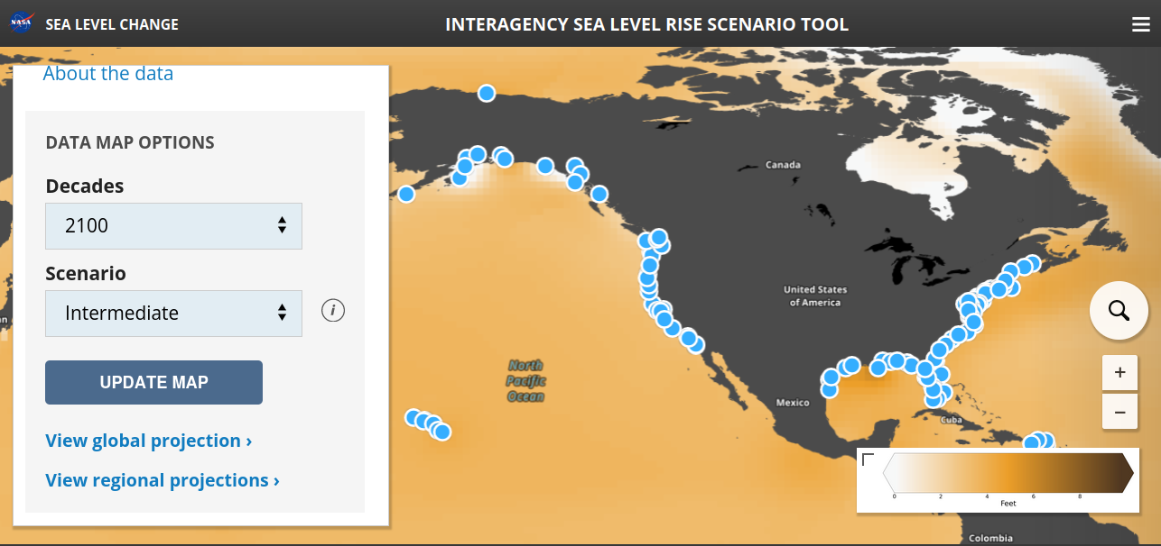Figure 19: NASA Interagency Sea Level Rise Scenario Tool [40]

#### NASA Flooding Analysis Tool

This tool was developed to facilitate decision-relevant assessments of how sea-level rise and other factors will affect the frequency of high-tide flooding across the United States. Users can view sea-level observations and assess past high-tide flooding frequency, view future changes in high-tide flooding frequency under the Interagency Sea-Level Rise Scenarios, view statistics and inflection points that support decision making.

Figure 20: NASA Flooding Analysis Tool [41]

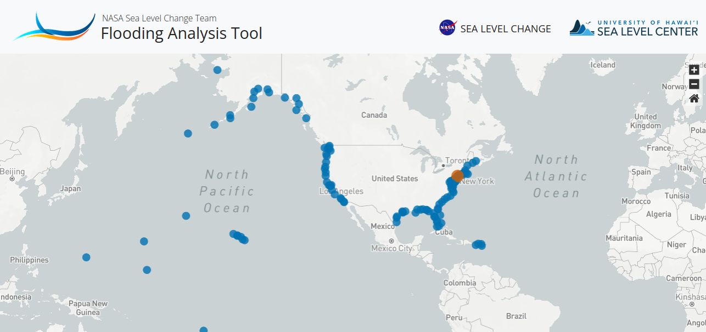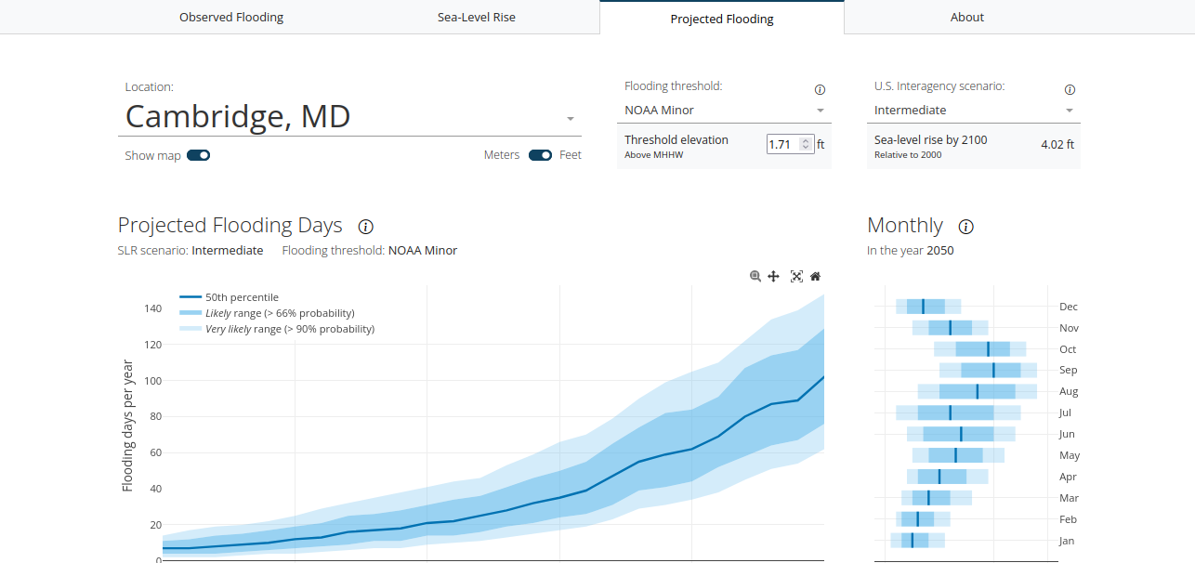

They use established SLR scenarios and flooding thresholds to demonstrate how the combined effects of SLR and nodal cycle modulations of tidal amplitude lead to acute inflections in projections of future HTF. Ensemble projections of twenty-first-century HTF frequency (Methods) are generated for 89 tide-gauge locations across the contiguous United States and US-affiliated Pacific and Caribbean islands [42].

This tool provides observed and projected flooding events in the tide gauge locations. For each single tide gauge location, user is able to select the flooding threshold whether from a list of predetermined NOAA and NWS ([National Weather Service](https://www.weather.gov/)) flooding thresholds or enter a **custom threshold height**. Predetermined threshold heights were obtained from the *CO-OPS API For Data Retrieval* [43] .Then, they will be able to see the flooding days per year for the selected tide gauge during 21st century, for each scenario and different likelihood levels.

### NOAA Sea Level Rise Viewer

It is a web mapping tool to visualize community-level impacts from coastal flooding or sea level rise. This tool provides plenty of features related to sea level rise including *Sea Level Rise, Local scenarios, mapping confidence, March Migration, Vulnerability, High Tide Flooding* for US and affliated coastal area*.* In all the features, the user is able to visulize the corresponding interactive maps by changing the water level. Each feature has its own mapping method, here we consider the sea level rise mapping feature, that provides a view to sea level rise and potential coastal flooding impact areas and water depth.

In mapping process, the mapping inputs include DEM, Tidal Surface in NAVD88 (North American Vertical Datum of 1988) values, and sea level rise values. Using an algebraic model, in ArcGIS spatial analysis, the Inundation maps are produced [44].

[a]

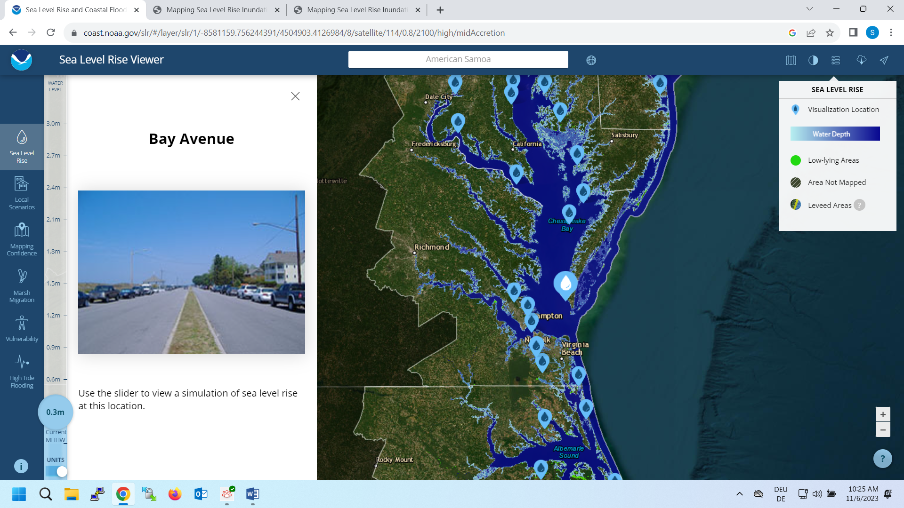

[b]

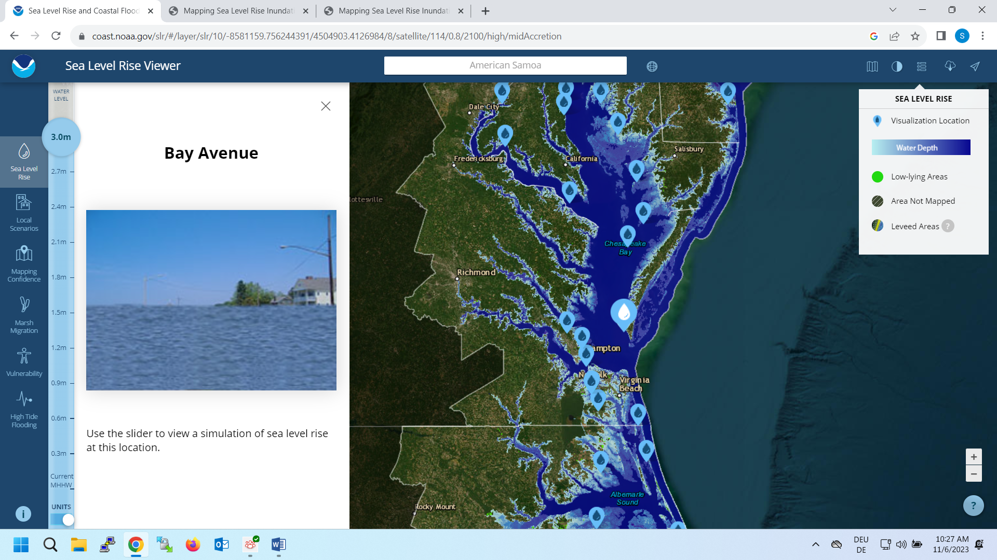

Figure 21: NOAA sea level rise viewer [45] (here sea level rise inundation tool for Bay Avenue with [a]-0.3 meters water level and [b]-3 meters water level)

The data and maps in this tool illustrate the scale of potential flooding, and do not account for erosion, subsidence, or future construction. Water levels are relative to Mean Higher High Water (MHHW) (excludes wind driven tides).

## Study Area

For the purpose of this study, a bounding box of the coastal area from 7 to 15 degrees East and from 53 to 56 degrees North is considered as the case study. The area contains 172,772 km², which includes the entire coastal area in Germany, southern Denmark and northwestern Poland, close to the German border.

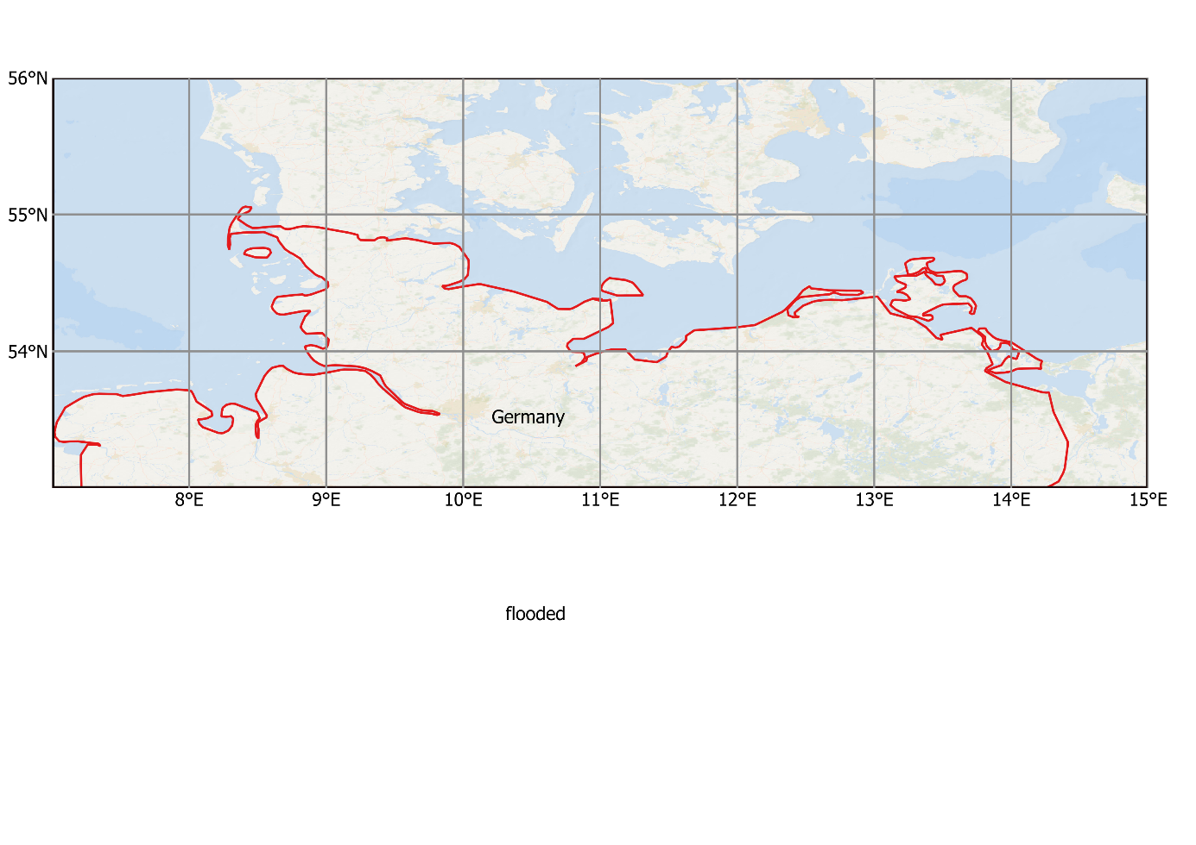

Figure 22: Study area

The total inhabitants of this area amount to 15,120,910 individuals based on the Census 2020. The population of the area is computed using Census 2020 demographic data, available on the WorldPop Hub data centre as spatial distribution of population in 2020 [46]. The data is in GeoTIFF format at a 30-arc resolution. Therefore, using zonal statistics in QGIS software, the vector file of the bounding box intersects with the Geotiff file of population and the ‘sum’ of population in the area is computed . More information about the process of zonal statistics is explained in the result chapter.

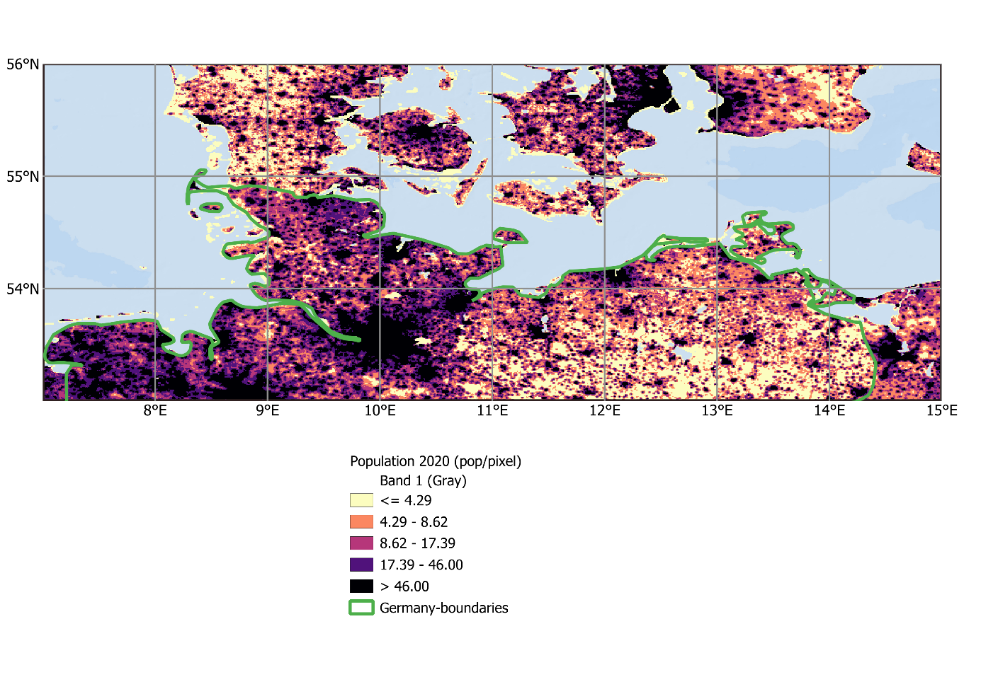

North Sea

Baltic Sea

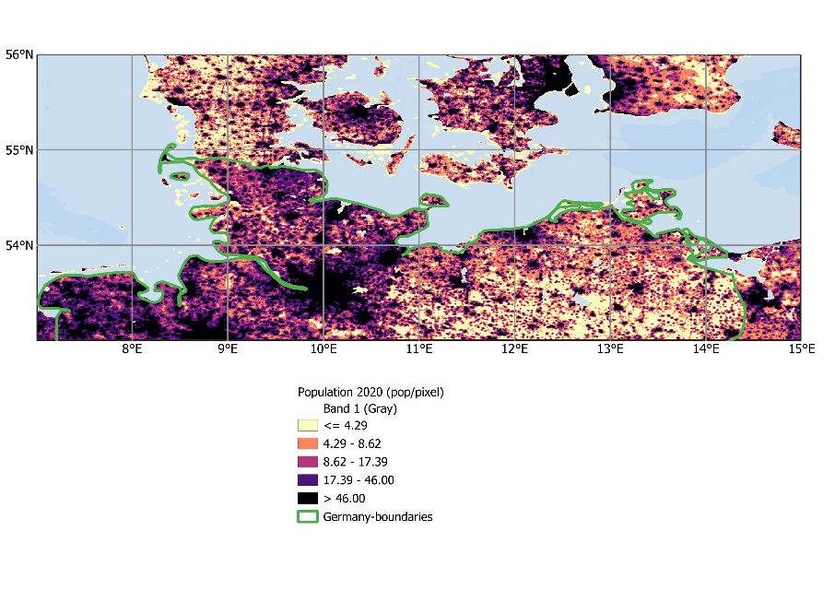

(Pop/km2)

Figure 23: Spatial distribution of population in 2020

The case study contains North Sea and Baltic Sea coastal area. The Baltic and North Sea coastal areas differ significantly in their characteristics. The Baltic Coast features minimal tidal ranges, diverse landscapes with sandy beaches, dunes, chalk cliffs, coastal forests, and wetlands. On the other hand, the North Sea coast boasts dramatic tidal ranges in the Wadden Sea, with landscapes shaped by human intervention, including mudflats, salt marshes, dunes, and moors [47].

# Data and Methodology

In order to evaluate coastal vulnerability caused by sea level rise during 21th century, flood maps for the study area are produced for the years 2020 to 2100. In our methodology, for future flood simulation, we assume that the coastal lands with elevation lower than future sea level height will be flooded. Digital Elevation Model (DEM) are considered to characterize the land surface. Therefore, comparing the DEM of a coastal area and the future sea level height of the area, flood plains are identified.

It is assumed that future’s DEM of the study area will stay the same as 2022. It is also assumed that the sea level will change in the future, with the same rate as it has changed during 2005-2015.

Thus, at the first step, to simply model the complex system of a rising sea level, we simulate the future sea level height. For this purpose, a base sea level is considered and the sea level change, for each future year, is simulated using observed annual sea level rise trend. Hence, the datasets which build the flood model include:

* Mean Sea Level Surface 1995-2014
* IPCC realistic Sea Level Projection for the year 2020 (under scenario SSP245)
* Annual sea level rise rate between 1-2005 to 12-2015
* Geoid elevation
* Bedrock elevation.

The first three datasets are used to simulate future sea level height and the last two datasets define the DEM.

It is imperative to emphasize that the chosen methodology and datasets exhibit a global applicability, with the selection of a specific case study primarily serving the purpose of enhancing visualization and streamlining computational complexity. Consequently, each step of the process is universally applicable across diverse geographic regions, thanks to the global datasets source from which the utilized data were drawn. This underscores the potential for conducting visualization and computation at a global scale.

## Workflow

The research follows a workflow based on the introduced flood simulation model. The workflow of the study contains:

**Data Planning:** Involves the exploration of dataset providers to acquire the necessary data. In this stage the temporal and spatial resolution of the data and their geographical coverage are investigated.

**Data Pre-processing:** Here, the acquired data undergo thorough preparations to suit the computational requirements. The nature of this step varies significantly depending on factors such as the format, complexity, and size of the original datasets.

**Computation Phase:** During this stage, the preprocessed data are combined, allowing the application of the introduced model to compute sea level heights and generate flood maps for the study area. It is noteworthy that both the preprocessing and computation phases are carried out through the use of the Python programming language within a Jupyter Notebook environment[1].

**Analyzing the results:** Following the simulation of the floodplain in the study area, vulnerability is assessed by analyzing the inundated land surfaces. Additionally, to examine the socioeconomic impact of the coastal flood, the affected population by the flood is estimated for current and future inhabitants.

## Sea Level Change for the base year

Sea level change projections dataset is associated with Working Group 1 (WG1) of the Sixth Assessment Report (AR6) of Intergovernmental Panel on Climate Change (IPCC) [2]. These projections are performed with respect to the baseline of 1995 to 2014 for future epochs from 2020 to 2150. Therefore, for computing sea level height for the 2020, we need to add the map of sea level change for 2020 to the mean sea surface over the period 1995 to 2014.

Since this thesis aims to take the regional variability into account, the relative sea level projections dataset is employed (under ar6-regional-confidence.zip) [48]. The dataset is based on updated simulations obtained from the Coupled Model Intercomparison Project Phase 6 (CMIP6) ensemble. These simulations enable the projection of ocean dynamic sea level contributions to regional sea level change [2]. Data of regional analysis are available in low confidence and medium confidence. Here we focus on medium confidence which correspond to more agreement[2]. We also consider scenario SSP2-4.5 that is *the middle of the road* scenario[3]. In scenario SSP245, the global temperature rises 2.7°C by the end of the century [49]. The impacts of all contributors of sea level change are studied individually and totally in different datasets. These contributors include: thermal expansion, Greenland and Antarctic ice sheet contributions, glacier melt, vertical land motion and land-water storage (Figure 24). Since no single model can directly compute all these contributions, they are calculated individually and subsequently combined[2]. Thus, for the purpose of this study, which is producing flood map by sea level rise, the total combination of all drivers is used.

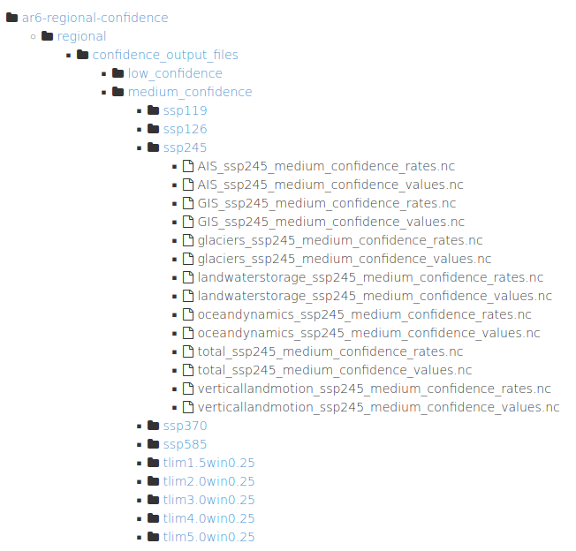

Figure 24: the structure of IPCC regional sea level rise projection dataset

IPCC sea level change is comprised of netcdf files. For each scenario, there are 6 pairs of files, each containing information on sea level change values and rates contributed by various factors. Additionally, there is one pair of files that presents the combined value and rate of all these contributors (Figure 24). In this context, we specifically focus on the data associated with the total combination for the scenario ssp245.

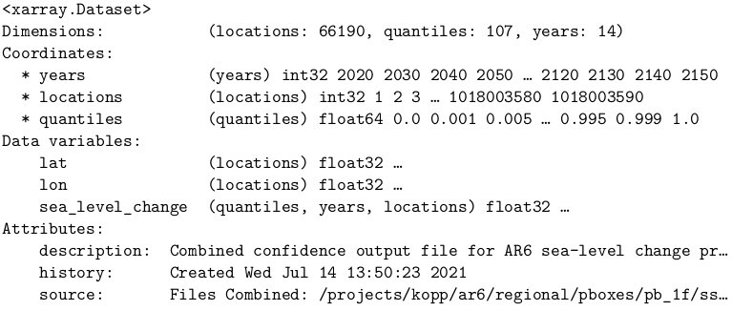

Figure 25: the structure of IPCC SSP2-45 scenario of sea level change projections

The dataset utilizes a geographical coordinate system with a 10-year temporal resolution, spanning from 2020 to 2150. It encompasses 1030 non-grid Tide Gauge data points and 65190 grid points related to altimetry measurements. The geographical resolution for the altimetry dataset is 1 degree of longitude eastward and 1 degree of latitude northward, covering the entire Earth from -180 degrees west longitude to 180 degrees east longitude and from -90 degrees south latitude to 90 degrees north latitude.

The coordinates and dimensions of the dataset are **years, locations and quantiles**.

* The years, include 14 time-epochs from **2020 to 2150.**
* The locations coordinate, is a unique id for each lat-lon point of data (66190 locations that contain 65160 altimetry and 1030 tide gauge data points).
* The quantile refers to the likelihood and is a value between 0 to 1.
* The variables of the dataset are latitude, longitude and sea level change

**IPCC-Data Preprocessing**

To narrow down the complexity of uncertainty of the dataset we focus on quantile=0.5 as median. Also, just altimetry data is intended. So, the tide gauge data (with non-grid or non-integer latitude or longitude) are dropped from the process.

In order to make the dataset compatible for the GIS environment and geospatial tools we need to have the latitude and longitude in the dimensions. Therefore, the structure of the data has been changed using **Scipy-interpolation** and **Rasterio** library. The result is a raster map (geotiff) which is readable in GIS software (Figure 26).

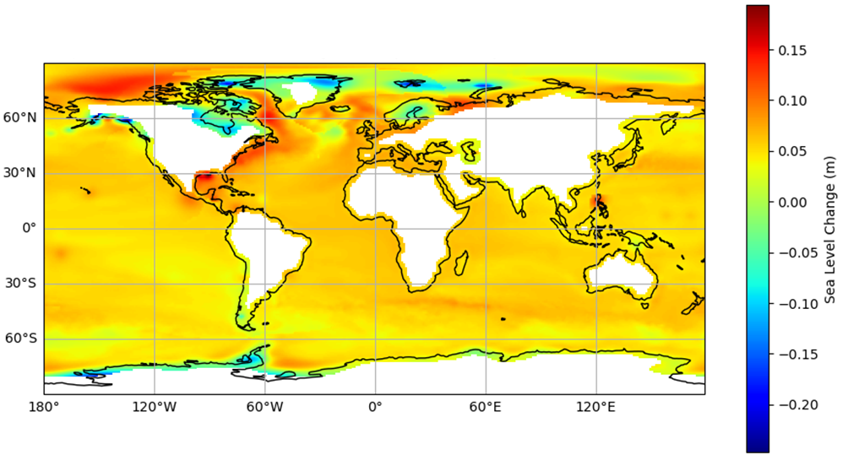

Figure 26: IPCC sea level change projection for the year 2020 relative to the baseline 1995-2014 for the scenario SSP2-45

As illustrated in the Figure 26, under SSP245 scenario, in 2020, sea level is projected to rise up to 19.4 cm and to fall down to 24.7 cm relative to 1995-2014. The highest fall is projected for the Greenland and Antarctic ice sheets’s surroundings. This phenomenon is due to the processess including GIA, the elevation-mass balance feedback in Greenland, due to SMB, and MISI in Antarctic that lower the sea level around the ice sheets and arise the sea level in the distance 2000 km which corresponds to the highest rise which is projected for Southeastern US and Mexico Southwest.

In the next step, to investigate the sea level change for study area, the global SLC data is clipped with the shapefile of the study area using Warp function of *Gdal* library.

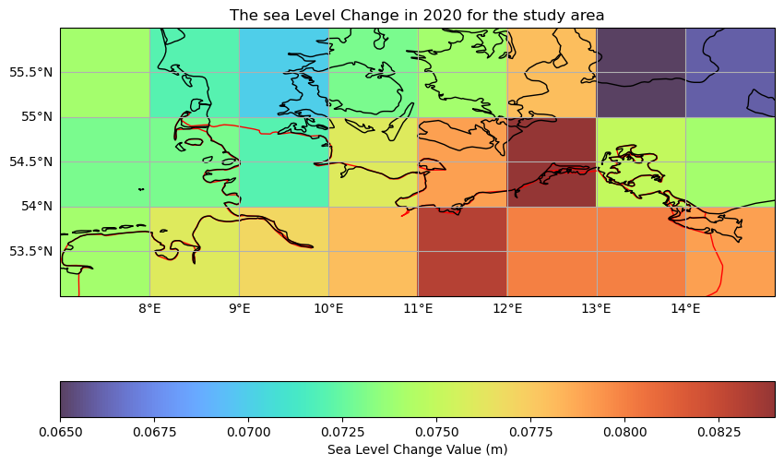

Figure 27: IPCC sea level change SSP245 projection for the year 2020 in the

German coastal area

At the scale of the study area, which extends 3 degrees latitudes and 8 degrees longitude, it is difficult to interpret the sea level change with 1 degree resolution. However, as it is shown in the figure 27, the sea level for the study area, is projected to rise from 65 mm to 84 mm, with an average of 75 mm and standard deviation of 4.5 mm (acquired with gdalinfo).

## Sea Level Rise Trend between 2005-01 to 2015-12

The sea level rise trend dataset has been obtained through the application of a global fingerprint inversion technique. The global mean sea level budget is derived by globally averaging all individual sea level rise components for each month and deriving a trend from the resulting time series over a chosen period (here 2005-01 till 2015-12). The base inversion setup for producing the inversion map includes input data from Jason-altimetry and *GRACE* gravity data [50].

In the context of future flood simulations, the total sea level, i.e. the sum of mass and steric components is retrieved from the original dataset. The sea level trend map is a NetCDF file of the annual rate with unit of meters per year.

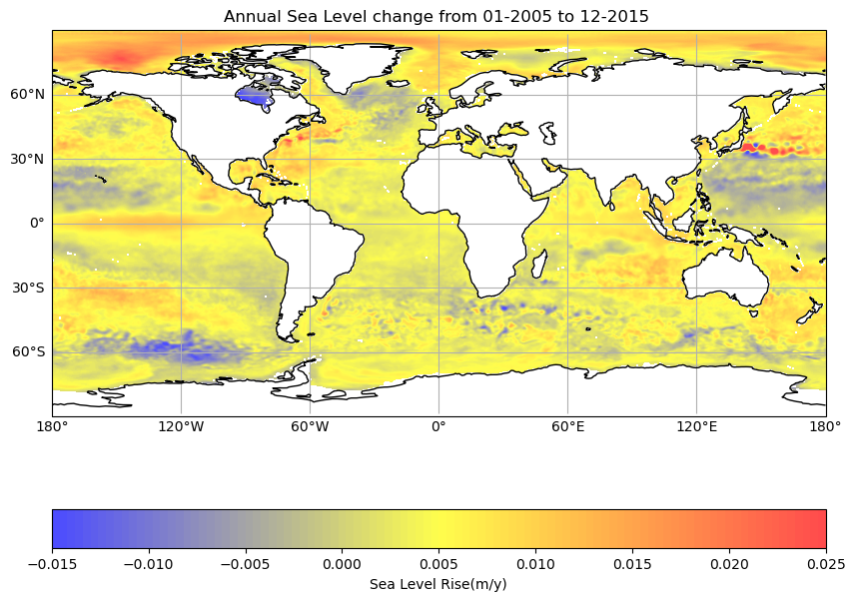

Figure 28: Global sea level rise trend from 01-2005 to 12-2015 (m/y)

**Sea Level Trend Data Preprocessing**

While sea level rises, more and more coastal lands will be under water and the shoreline will extent into the land. However, since the observed sea level trend map covers only the past ocean surface, we need to extrapolate the data for the study area to be able to evaluate its potential effect for the future ocean extent (As in IPCC dataset we see the projection until 2 degrees from the current shoreline).

In order to do the extrapolation, we need to have the trend file as point shapefile and then extrapolate them. So, in the first step, we extract data as a point shapefile using *Shapely* library. In the next step, the point shapefile is interpolated for the bounding box of the study area by Inverse Distance Weight (IDW) algorithm with the *Gdal* library, the result is illustrated in the Figure 29.

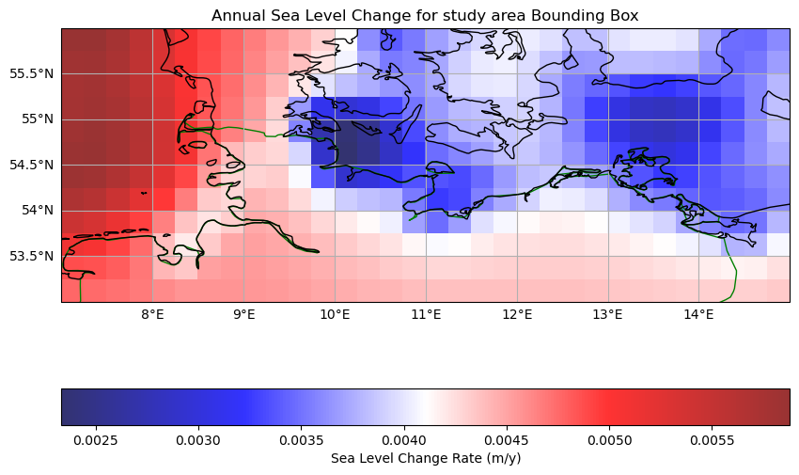

Figure 29: Extrapolated sea level trend from 01-2005 to 12-2015 for the study area

The observation of global sea level rise during 2005 to 2015 shows a range of -15 to 25 mm change per year (Figure 28). However, this range for the study area, narrows to 2.3 to 5.8 mm per year (Figure 29). Observed sea level rise for the study area shows two different patterns in the Baltic and North Sea coastal area, which endorse different features and behavior of these two seas. Therefore, it is expected that future sea level rise will follow the same pattern. In the Baltic coastal study area, the sea level has a trend between 2.3 to 4 mm/year, while the same value for Northern coastal area varies between 4.1 to 5.8 mm/year.

## The Geoid data

The Geoid dataset is sourced from *ETOPO 2020*. *ETOPO 2022* is a release of *NOAA’s**Earth TOPOgraphy* dataset. It is a full-coverage, seamless, gridded topographic and bathymetric bare-earth elevation dataset [51]. To obtain the Geoid of the study area, the high-resolution grid tiles in 15 arc seconds resolution (ETOPO_2022_v1_15s_N60E000_geoid.tif) is downloaded from *ETOPO 2020* Geoid height Geotiff dataset [52] and Using *Gdal* library, the bonding box mask is applied on the Geoid tile to clip the Geoid of the case study (Figure 30).

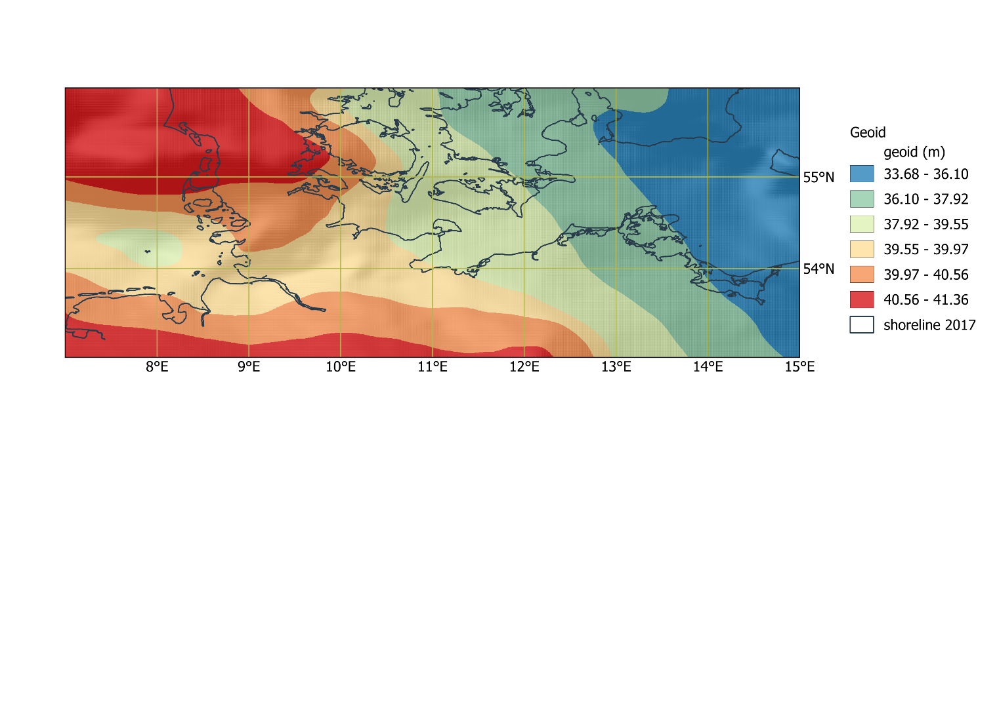

Figure 30: Geoid elevation of the study area

The Geoid elevation of the study area is between 33.68 to 41.36 m, with mean elevation of 38.63 m and standard deviation of 2 m. Geoid elevation in North sea of the study area shows higher value with respect to the Baltic sea. The Geoid of the Baltic side is lower than 40 m, while the Geoid of the North Sea side is higher than 40 m.

## Digital Elevation Model and Bedrock Elevation

All *ETOPO* tiles are in horizontal WGS84 geographic coordinates (EPSG:4326) and referenced in meters relative to the Earth Gravitational Model of 2008 (EGM2008) geoid surface (EPSG:3855). Each tile comes with an accompanying geoid tile for converting EGM2008 geoid heights into WGS84 ellipsoid elevation heights (EPSG:4979) [51].

To convert a given tile from EGM2008 to WGS84-referenced elevations, we need to add the values of the elevation tile to the geoid-height tile:

**ETOPO Elevation (EGM2008) + GEOID = WGS84 Elevation** [51]

Therefore, to compute the elevation model, the bedrock elevation needs to be added to the Geoid map.

### Bedrock Elevation

Bedrock elevation of the study area is obtained from the *ETOPO 2022* Bedrock model with 15 arc-second resolution and is Extracted from the Grid Extractor function for the bounding box as a Geotiff file [53] .

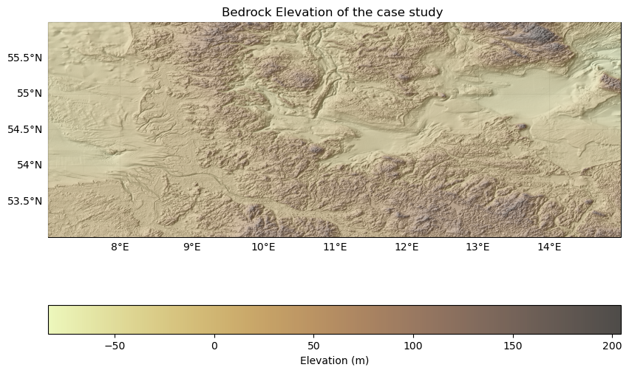

Figure 31: Bedrock Elevation of the study area

The Bedrock elevation of the study area spans from -47 to 165 meters.

### Digital Elevation Model

To create the DEM, we start by examining the Geoid and Bedrock Elevation maps. We check first the requirement of computation like resolution, coordinate reference system, and the extent of the input data. If needed, reprojection and resampling should be applied to adjust them. Utilizing *GetGeoTransform* and *GetProjection* functions in the *Gdal* library, shows that both maps have the same resolution (0.00417 degrees) and use the WGS84 ellipsoid for coordinates. The area is already defined by a bounding box, consequently, the input datasets require no modification in preparation for DEM computation. Therefore Geoid and Bedrock are integrated using the *calc.py* function of the *Gdal* library. The resulted DEM is shown in Figure 32. The DEM of the study area spans from -45 to 222 meters. The lowest values related to the elevation in both Baltic and North Sea, with no visible pattern between the two coastal areas.

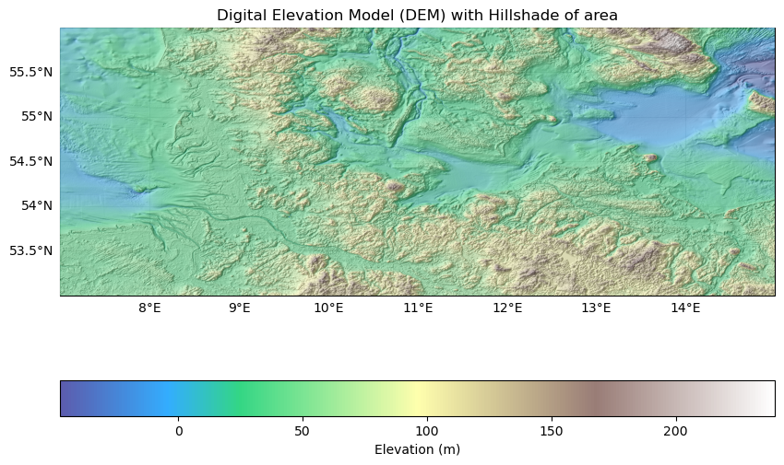

Figure 32: DEM of the study area

## Mean Sea Surface

The mean sea surface (MSS) is the time-averaged physical height of the oceans’ surface. In order to extract MSS of 1994-2015 of the study area, which is the baseline for the sea level change projection, DTU15MSS dataset is utilized. The DTU15MSS is the latest release of the global high resolution mean sea surface from *DTU* (Technical University of Denmark) Space. The major new advance leading up to the release of this *DTU15MSS* the use of an improved 4 years *Cryosat-2 LRM, SAR* and SAR-In data record and the downweighting of *ICESat* data used previously in the Arctic Ocean for DTU10MSS and DTU13MSS [54].

In this research, the NetCDF dataset of *DT15MSS* with a 1-minute resolution for Mean Sea Surface is employed. Subsequently, the dataset is transformed into Geotif format using the QGIS software. In the next step, the global MSS is clipped for the study area bounding box using the *Gdal* library (Figure 33).

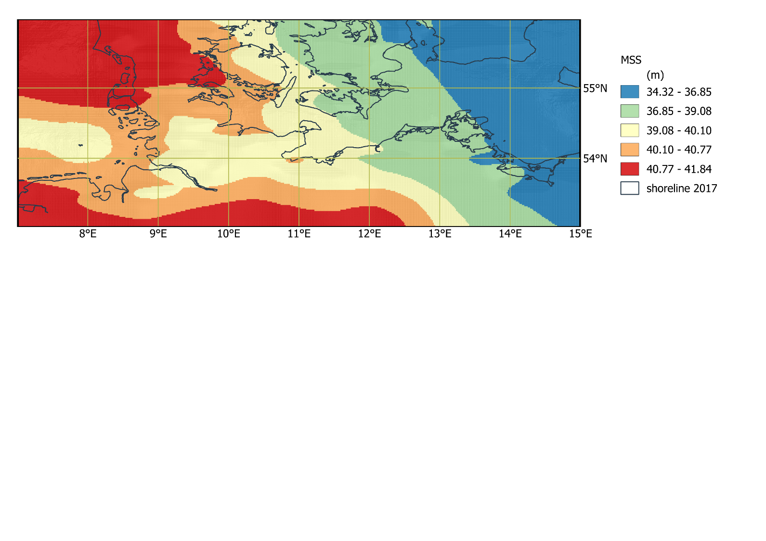

Figure 33: Mean Sea Surface of the study area

The MSS of the study area ranges from 34.3 to 41.8 with mean value of 39 m and STD of 2 meters. The same pattern as Geoid is also visible for MSS (higher MSS in the North Sea costal area and lower MSS in Baltic costal area). While the MSS of the Baltic side is lower than 39 m, it is higher than this value in North Sea coastal side of the area.

Table 2 shows a summery of the utilized data for producing the inundation maps.

Table 2: Input data for flood simulation

|  |  |  |  |  |  |  |  |  |
| --- | --- | --- | --- | --- | --- | --- | --- | --- |
| Name of the original dataset | Data provider | Data Format | Data reference | Geographical resolution | Geographical coverage | Data type | Temporal coverage | Access to the dataset |
| AR6 Regional Confidence | IPCC AR6 WG1 | NetCDF | CMIP6 | 1 degree | Global | projected | 2020-2150 | https://zenodo.org/record/5914710 |
| Sea Level Rise Trend between 2005-01 to 2015-12 | [55] | NetCDF | GRACE | 0.25 degree | Global | observed | 2005-01 to 2015-12 | [55] |
| ETOPO_2022_v1_15s_N60E000_geoid | NOAA’s Earth TOPOgraphy (ETOPO2022) | Geotiff | ICESat-2 lidar satellite | 15 arc-seconds | Global | observed | 2022 | [53] |
| Bedrock Elevation | NOAA’s Earth TOPOgraphy (ETOPO2022) | Geotiff | ICESat-2 lidar satellite | 15 arc-seconds | Global | observed | 2022 | [53] |
| Global Mean Sea Surface (DTU15_MSS) | DTU space | NetCDF | ESA Cryosat-2 LRM, SAR and SAR-In | 1 minute | Global | observed | 1994-2015 | https://ftp.space.dtu.dk/pub/DTU15/1_MIN/ |

## Computation’s pre-requirements

In order to integrate all the input layers together, they should share common attributes. Specifically, they must be in the same coordinate reference system, possess matching extents (in cases of disparity, the smallest extent takes precedence as the reference), and maintain consistent geographical resolution. The desired resolution for the computation output can be predefined. To ensure the highest simulation accuracy, the resolution of the dataset with the highest resolution, which here is DEM with 15 arc-second resolution, is utilized as the reference.

The output of the *GetGeoTransform* and *GetProjection* functions confirms identical Coordinate Reference Systems and extents, but different resolutions. Therefore, resampling is required. To address this, all input layers, except the DEM, including MSS, IPCC2020, and TRND, undergo resampling to align with the DEM's 15 arc-second resolution, a task executed using the *Gdal* library's *Warp* function. Now that all inputs share the same extent and resolution, they are primed for computational calculations.

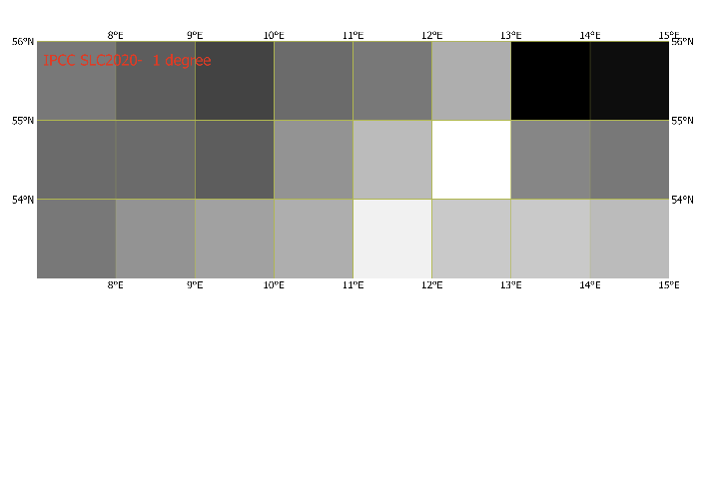 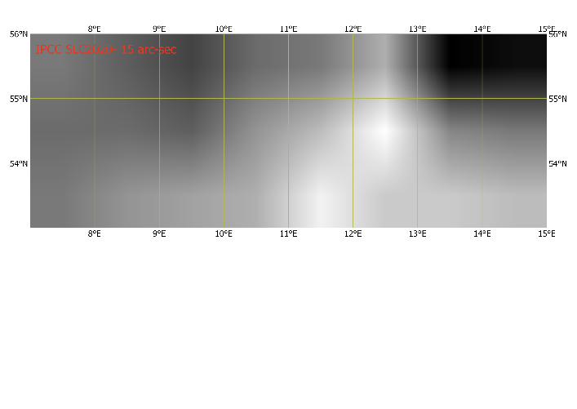

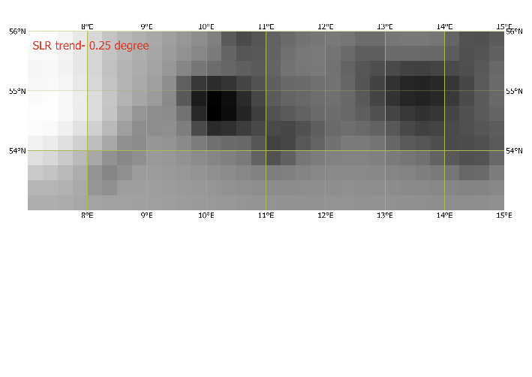 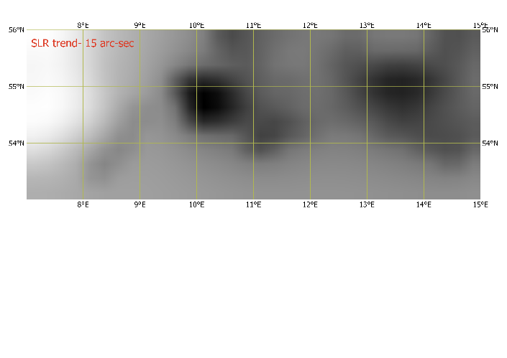

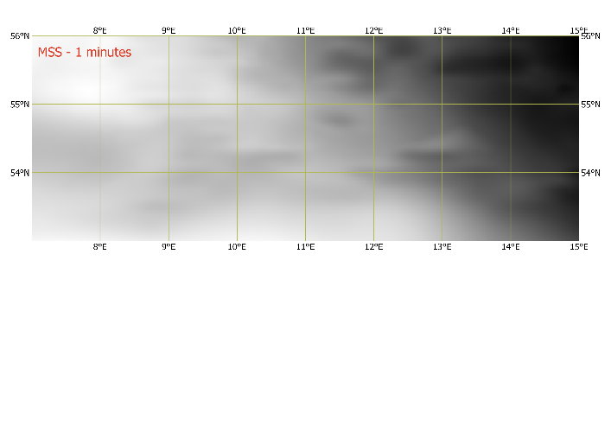 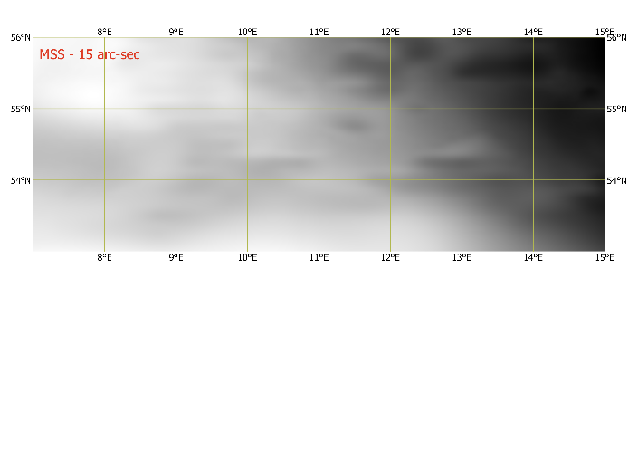

Figure 34: resampling the input data

# Result

## Simulation of Future Sea Level Height

To predict future sea level height based on the annual trend of sea level rise, we rely on establishing a reference point for this trend. This reference point is defined as the projected sea level for a designated base year (2020), as projected by the IPCC. The computation of this base reference involves the addition of the Mean Sea Surface value to the projected sea level change as estimated by the IPCC for the year 2020. Subsequently, for any given year, the sea level height is calculated by augmenting the base reference with the product of the difference between that year and 2020, and the annual trend value. In essence, the sea level height for the year denoted as 'N' can be expressed as:

**SLH_N = MSS + IPCC2020 + (N - 2020) x TRND**

To illustrate, provided in Appendix is a script exemplifying the computation of sea level height for the year 2100. To execute this, a designated output directory labeled as *"sea_level_maps"* is established. This directory encompasses the collection of projected sea level heights for every individual year within the aforementioned period. The process entails the implementation of *Gdal* raster calculations, which are executed iteratively through a loop spanning from 2020 to 2100.

As an illustrative demonstration, we present visualizations of sea level heights for four arbitrarily chosen years.

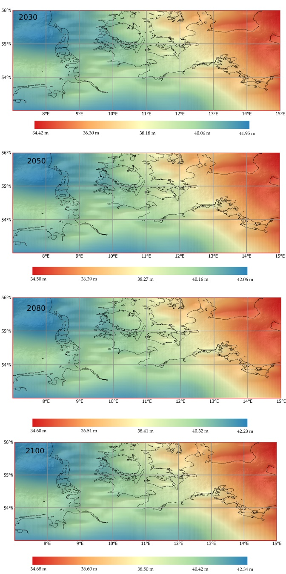 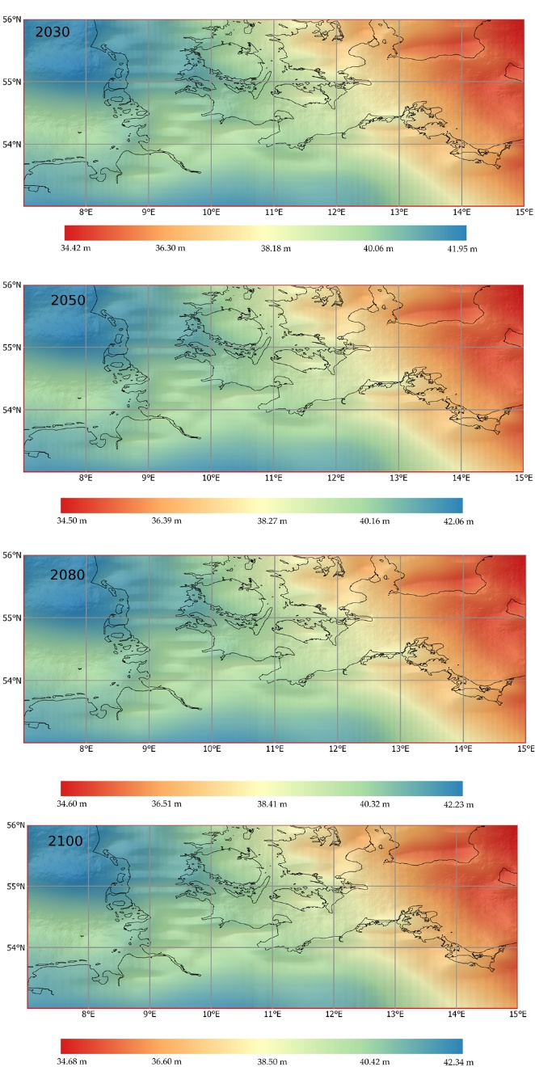

Figure 35: simulated sea level height 2020-2100

The result of sea level height simulation for the study area identifies a rising pattern from 2020 to 2100. It is expected that the range of SSH increase from 34.39- 41.89 m in 2020 to 34.68- 42.34 m in 2100 in the coastal area of Baltic and North sea. This illustrates a change in SSH from 0.187 to 0.47 m for the study area from 2020-2100. This finding showcases the impact of observed sea level rise trend (2005-2015) which is between 0.0023 to 0.0058 m/y for the study area.

As it is shown in the Figure 36, the North Sea part of the area will face a rise between 0.36-0.47 m while Baltic sea part of the area is expected to rise between 0.24-0.36 m from 2020 to 2100.

Figure 37 provides more details about the change in the sea surface height for different years during 2020-2100.

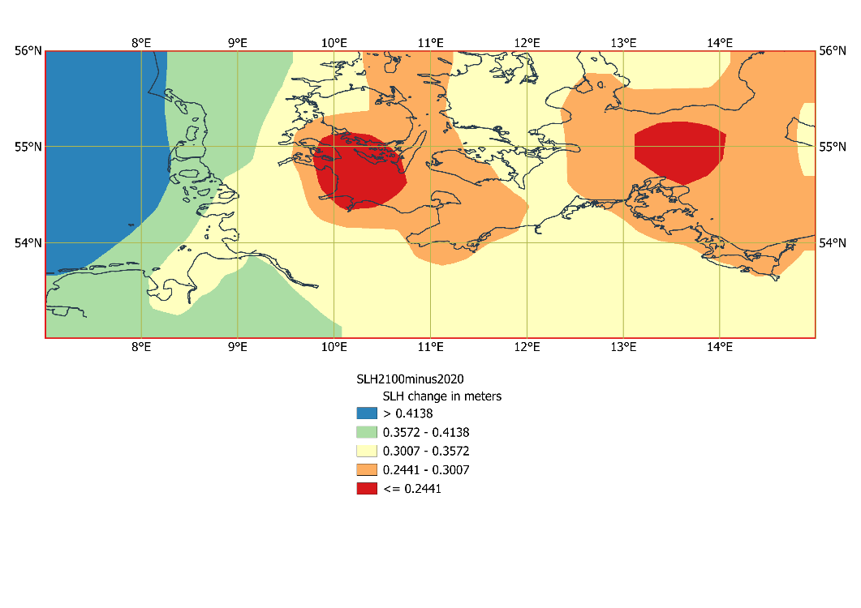

Figure 36: simulated change in the sea level height in 2100 with respect to 2020

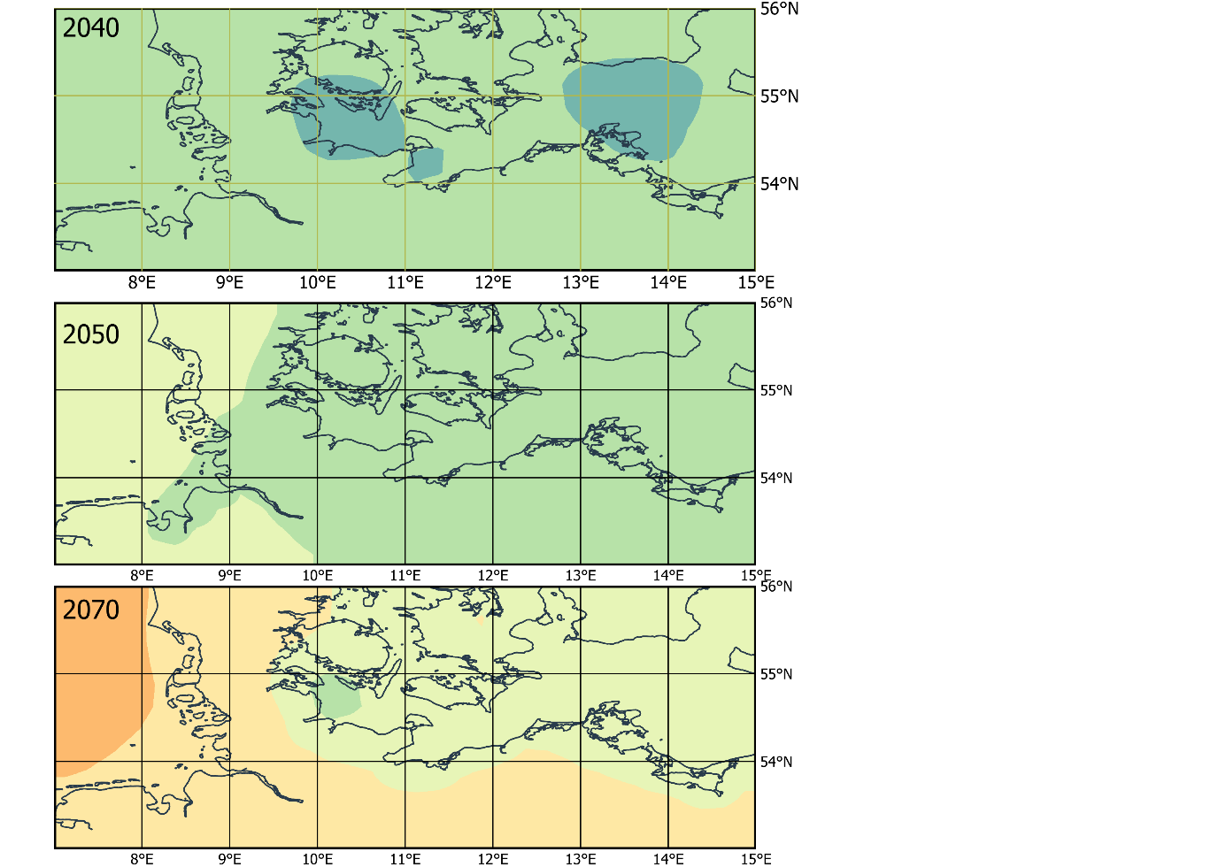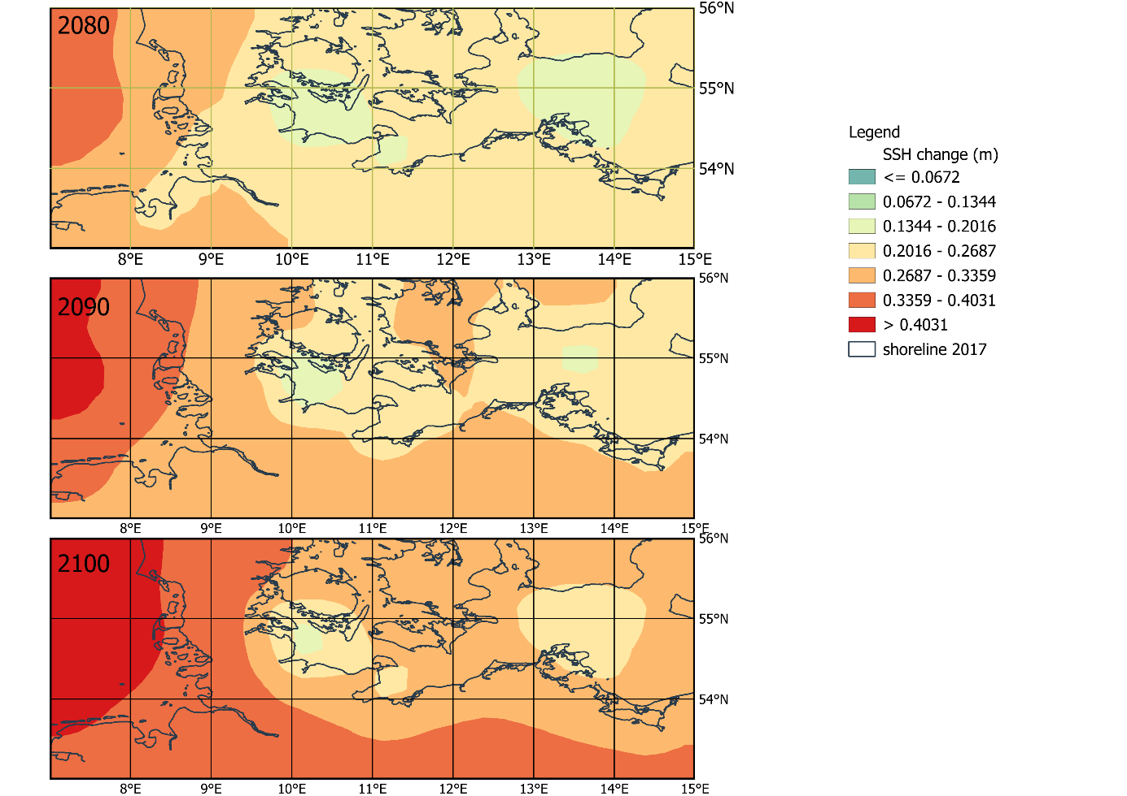

Figure 37: simulated change in the sea surface height during 21th century with respect to 2020

## Identifying Flood Plain

By possessing the sea level height data for the respective years and integrating it with the topography of the study area, we gain the capability to delineate areas that might be subject to flooding. This entails identifying all pixels with elevations lower than the corresponding sea level height. For instance, considering the year 'N', the region prone to inundation can be defined as:

**Flood = where (SLH_N => DEM)**

For the computation of flood maps spanning from 2020 to 2100, we extend the script to encompass a looping mechanism that iterates through each individual year. This iterative process involves utilizing the *gdal_calc.py* function to calculate the flooded areas. The outcomes of these calculations are systematically stored within a designated directory named *"flood_maps".* This comprehensive approach ensures that flood maps are generated for each respective year, effectively capturing the evolving inundation patterns over the entire time range.

Here as some examples, the simulated flood map for 4 arbitrary years are visualized.

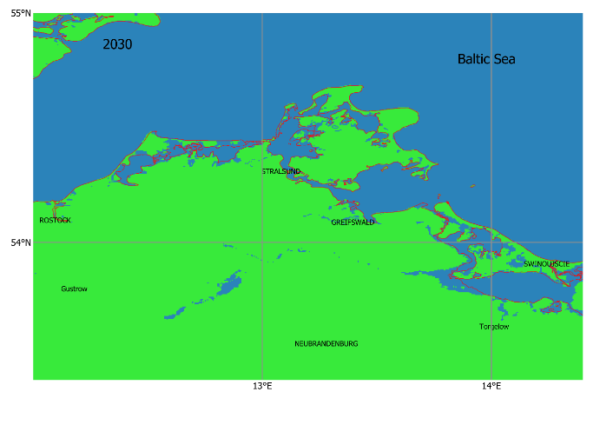 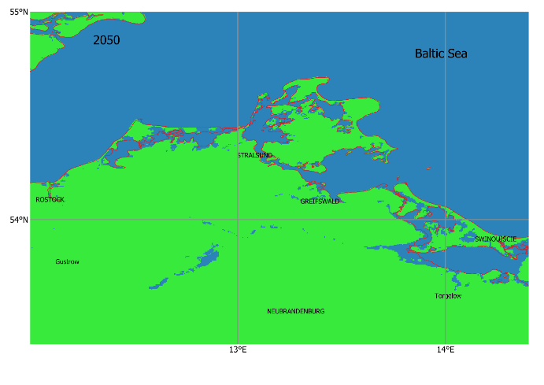

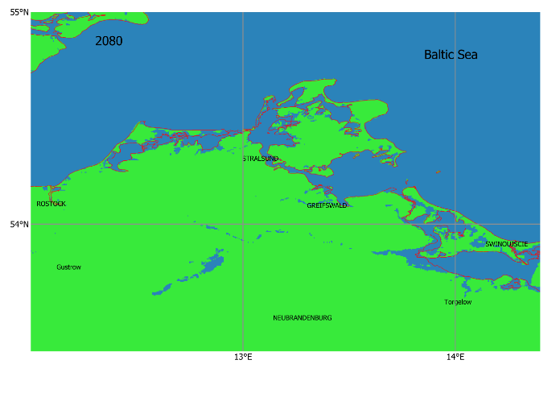 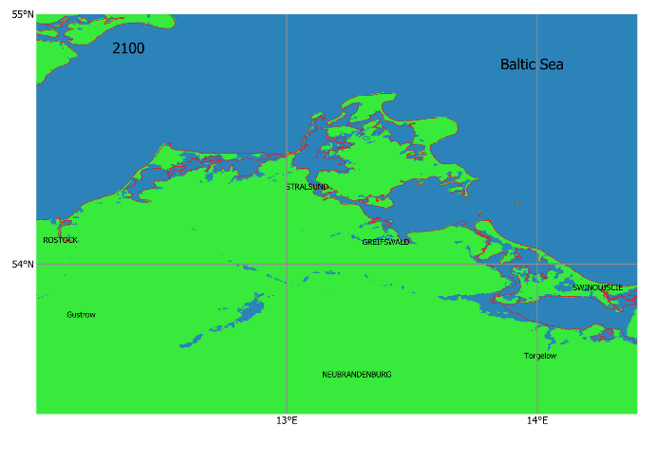

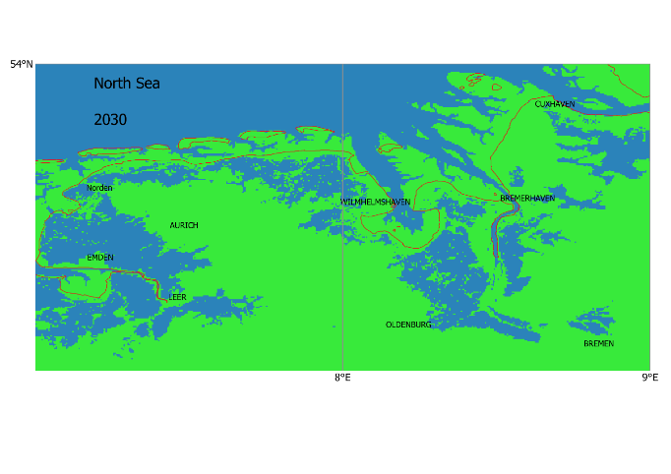 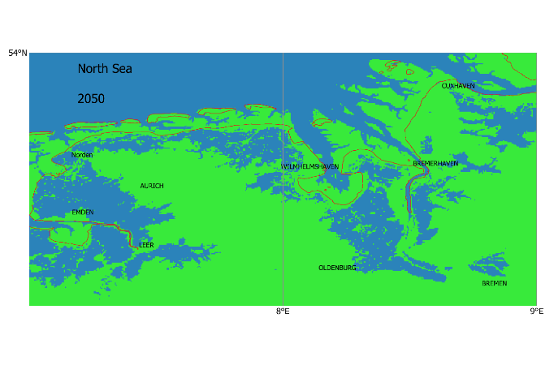

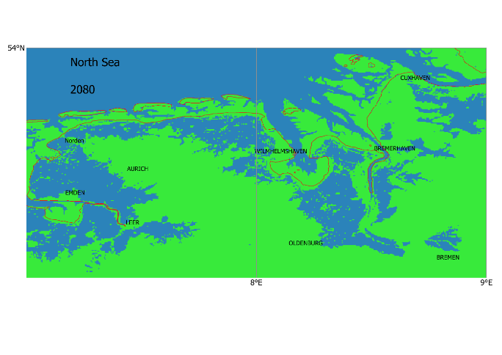 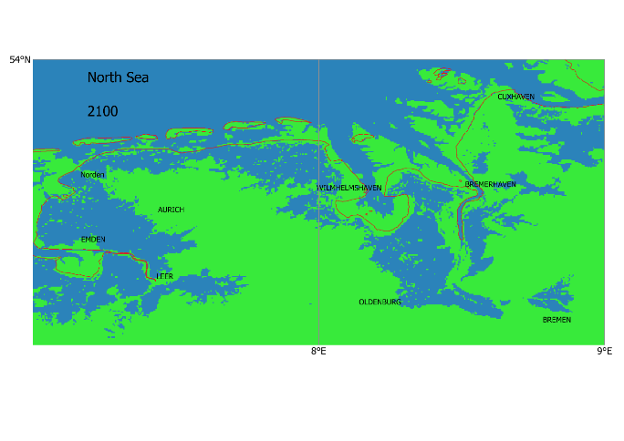

Figure 38: The result of flood simulation due to SLR in two sample areas in North and Baltic Seas

In the context of this research, it is crucial to emphasize that the input data available for analysis is inherently limited, and these data do not encompass all the influential parameters responsible for either triggering or mitigating flood events. It is imperative to recognize that there is substantial room for improvement in both the model and the overall research approach, which can lead to more precise and reliable results. This acknowledgement underscores the necessity of further development and refinement in order to enhance the accuracy and comprehensiveness of our findings[4].

Figure 39 illustrates flooded regions in a sample areas in the North Sea coastal area during 2020-2100 with respect to 2020.

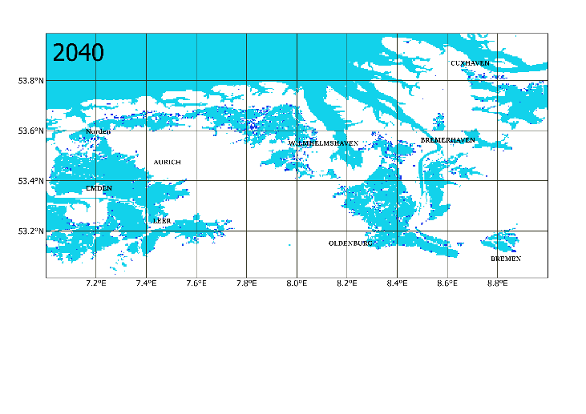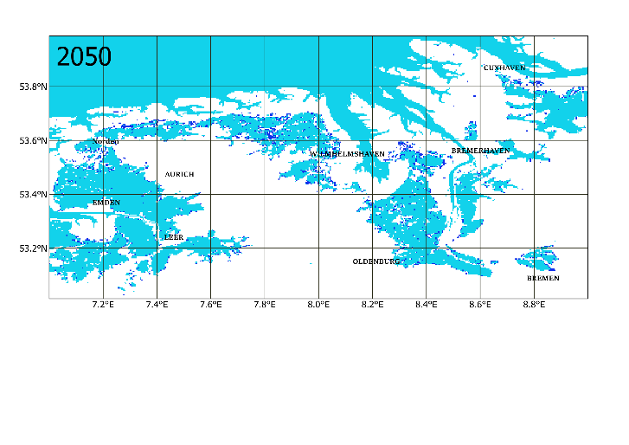

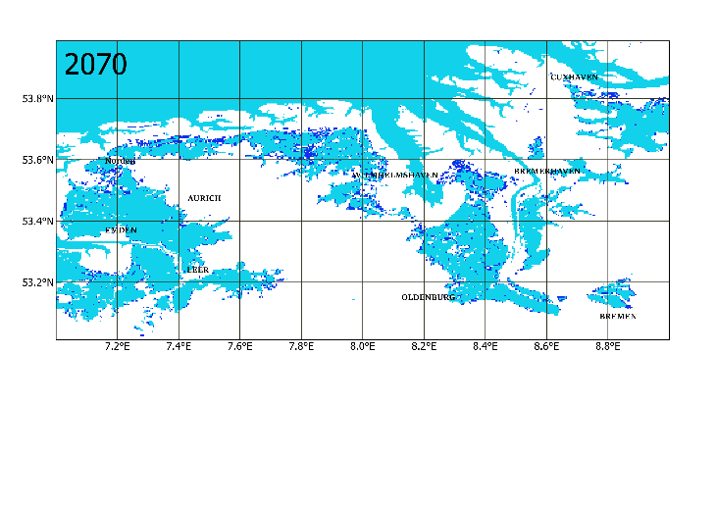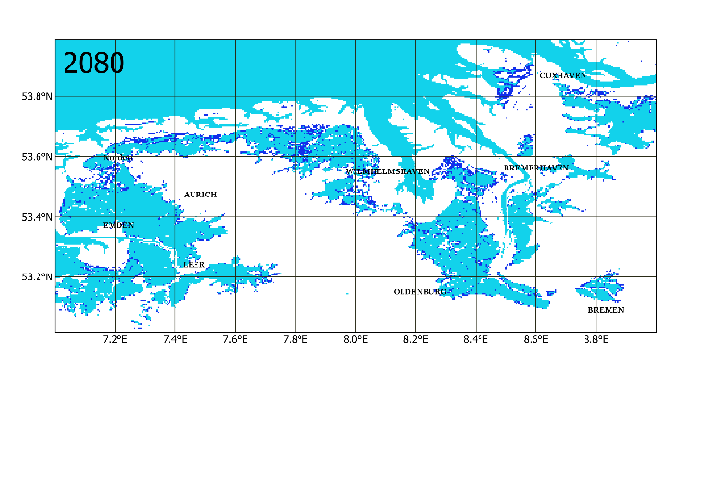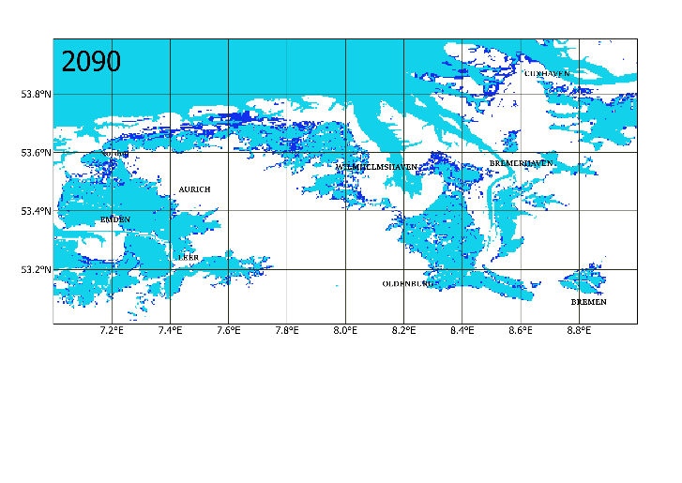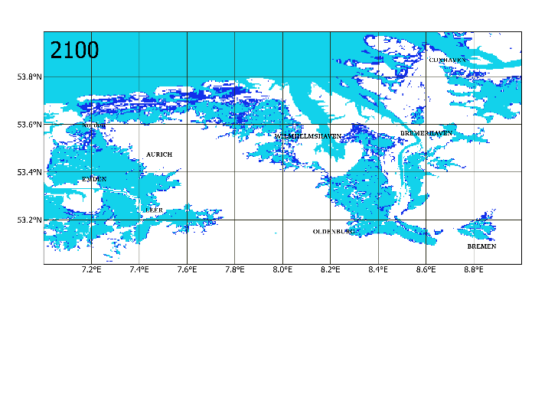

Figure 39: simulated flood plains in a sample area in North Sea during 2020-2100

Figure 40 shows flooded regions in a sample areas in the Baltic coastal area during 2020-2100 with respect to 2020. Comparing the flood plains in the two North and Baltic Seas’ coastal area shows that North coastal area is expected to be more vulnerable with respect to the SLR, however the risk of SLR-related flood in Baltic costal area will increase by the end of the century. It showcases the urgent necessity of adaptation strategies on the cities and settlements by the sea.

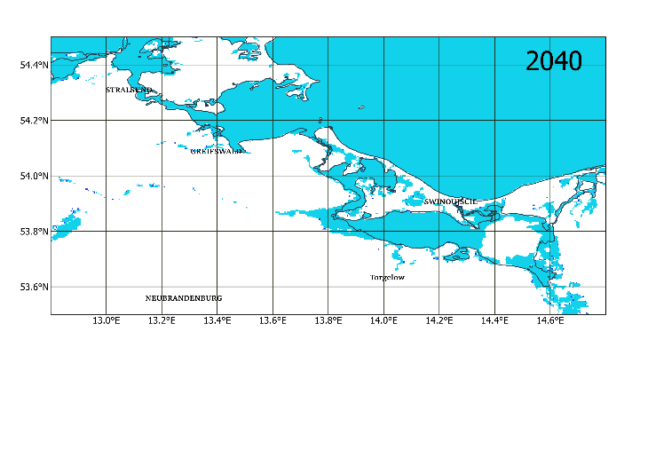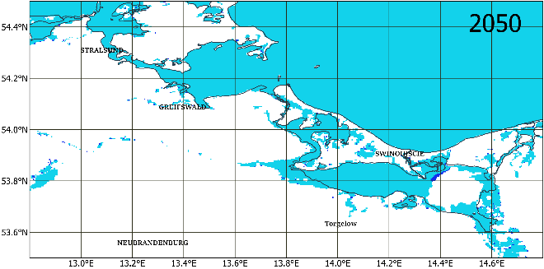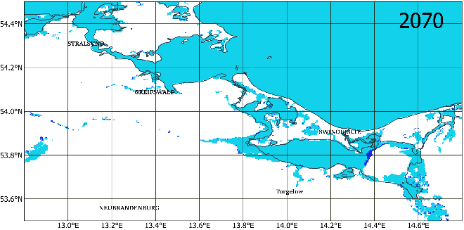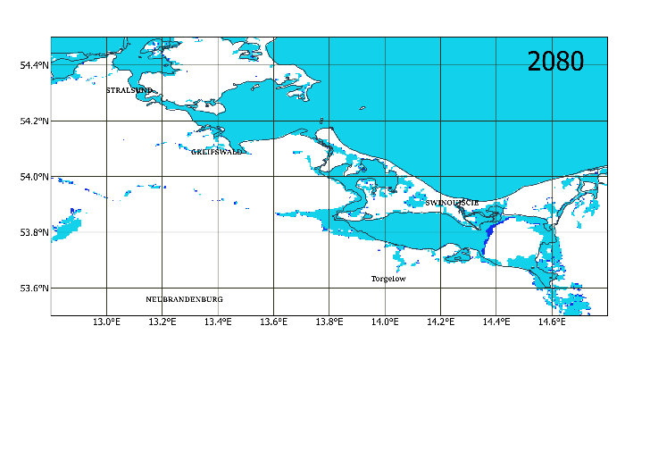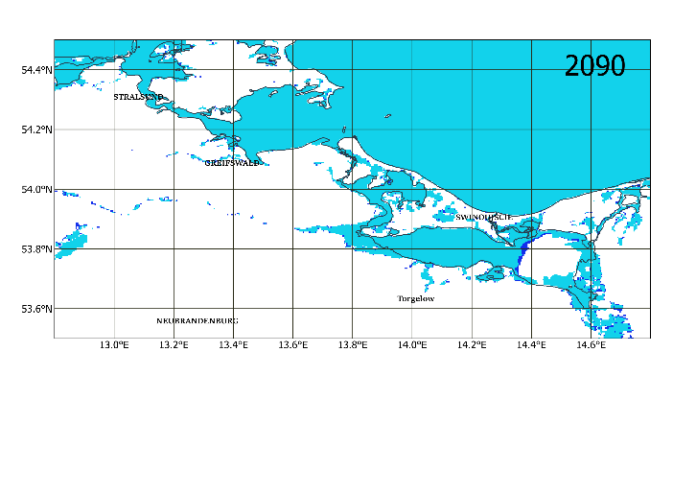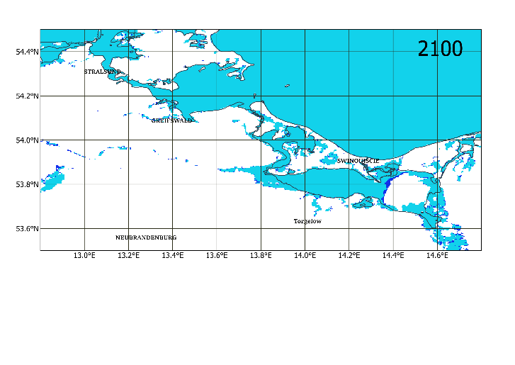

Figure 40: simulated flood plains in a sample Baltic coastal area during 2020-2100

### Analysis the inundated costal area

In order to assess the socio-economic consequences of the sea level rise in the coastal area, we investigate the surface area of the lands that will be flooded based on the simulation. Figure 41, demonstrates an exponential growth in potentially inundation in the Coastal area until the end of 21st century. For the study area, it is estimated that 1,942 km2 of the coastal area will be flooded due to SLR from 2020 to 2100, with the mean value of 24.3 km2/ year. The rate of inundation will increase sharply after 2080, as mean annual value of the inundation increases from 19.2 km2/ year during 2020-2080 to 39 km2/ year during 2080-2100.

Figure 41: Inundated surface area by SLR during 21 century

### Vulnerable population

To analyse the population vulnerability, we need to examine how many people would be affected by the coastal flood. Estimating the affected population involves with demographic uncertainties. Therefore, two approaches were employed: firstly, accounting for the vulnerability of the current population; secondly, projecting population changes using the SSP2 scenario, which aligns with the simulated sea level rise. This dual approach acknowledges the complexities in demographic estimation and data.

The current population data, sourced from the WorldPop hub [46], comprises a global Geotiff file with a 30 arc-second resolution, providing number of population per grid-cell for 2020. For future population estimations from 2020 to 2100, the SSP2 population projection is utilized [56]. This dataset, also a global Geotiff file at a 30 arc-second resolution, continues the estimates of total population per grid-cell based on the WorldPop dataset in a 5-year interval. The SSP2 projection aligns quantitatively with the IPCC Shared Socioeconomic Pathways (SSPs), ensuring consistency in projecting population distribution over the specified timeframe.

In both methodologies, the floodplain vector file is overlaid with the population spatial distribution geotiff file. This intersection allows for estimating the number of individuals within the flooded zones. The process employs the Zonal Statistics function from the rasterstats Python module, summarizing the total population count within the flooded areas based on the vector geometries of the simulated flood. The analysis for current population is performed for each year and in ten-year intervals for the future projected population.

Based on the results of the statistical analysis, it's estimated that during 2020 to 2100, 153,116 people of current inhabitants of the study area will face the risk of inundation in the coastal region due to sea level rise (Figure 42). If the observed trend of sea level continues to rise at the same rate as 2005 to 2015, it is expected that the number of in risk population will increase equal to 1,914 people per year.

Figure 42: Affected current population by the flood in the study area due to SLR, from 2020 to 2100 relative to 2020

In the second methodology, accounting for the projected population based on SSP2, it's estimated that the number of affected individuals will reach to 40,737 people of the future projected inhabitants (Figure 43).

The fall in the affected population in the last decade of the century is due to the drop in the number of projected population in the study area, otherwise the inundated land continues to expand as shown in the Figure 41.

Figure 43: Affected projected population by the flood in the study area due to SLR, from 2020 to 2100 relative to 2020

In both approaches, the substantial impact of the flood in the coastal area, attributed to sea level rise, is concerning. These results emphasize the critical need for adaptive strategies in the coastal region.

# Conclusion, Limitation and Future Development

This thesis is an initial exploration into the crucial issue of climate change-induced sea-level rise that will affect many lives, facilities, and lands in coastal areas in the future. Within the constraints of the research timeline, efforts were focused on a literature review of sea-level rise, exploring the sea-level data providers and platforms, and selecting the most proper data for the purpose of this study, defining the model for coastal flood simulation, and finding the auxiliary datasets for creating the simulation result, applying the model for a sample year data in QGIS software then, automating the model for a big dataset. Finally, it concluded to assessing the vulnerability of the land and population in the coastal area by estimating the surface area and the number of population in the floodplain during the period between 2020 to 2100.

Therefore, the main accomplishments of this work include:

* Investigating the subject of sea-level rise as a crucial aspect of climate change, concepts, state-of-the-art work in coastal vulnerabilities
* Investigating sea-level data providers and platforms, becoming familiar with climatographic and oceanographic datasets.
* The implementation of a flood simulation model in coastal areas
* Automation of future inundation maps at one-year intervals
* Assessing the surface area and number of inhabitants in the floodplain during 21st century.

In the area of sea-level rise research, a significant challenge is the uncertainty associated with predicting future sea-level rise. In spite of vast investigation and development in climate models, they can only provide projections under different scenarios, but the exact extent and timing of sea-level changes are still uncertain. This Additionally, coastal areas are complex systems with diverse ecosystems and human activities. It's challenging to capture all the variables accurately in flood simulations, including factors like land-use changes, infrastructure development, and human adaptation measures. Also, predicting extreme events, such as storm surges or tsunamis, adds another layer of complexity.

Thus, the model that is implemented in this work for future sea-level height simulation and inundation map simulation is only an initial simplified GIS approach that opens the door for future development. There's a variety of aspects to address and advance in the current study, including:

**Enhancing the Simulation Model:** Incorporating more inputs and diving more into the complexity of the model, including integrating VLM in the analysis to refine assumptions about DEM stability.

**Extend the study to encompass various climate change scenarios:** The model can be developed also by considering different climate change scenarios; therefore, the simulation will be for all scenarios, then the effect of Antarctic, as a game-changer, and other SLR contributors will be more investigated.

**Assessing more vulnerabilities indexes:** coastal vulnerability can be deeper analyzed by evaluating different land uses and facilities that will be exposed by coastal inundation. Moreover, the cost of damage to the facilities, lands and infrustructures can be investigated.

**Integration of more advanced GIS tools for visualizations:** The result of flood simulation can be better visualized by implementing an interactive WebGIS platform. Moreover, due to the fact the GIS tools used in the programming are available in QGIS, it could be defined as a QGIS plugin, which later can be used by future researchers in SLR.

**Expanding the scope of the research:** given that the data used in this study are globally available, the research can be expanded to a global scale.

# Bibliography

|  |  |
| --- | --- |
| [1] | "European Environmental Agency," Global and European sea level rise, 2022. [Online]. Available: https://www.eea.europa.eu/ims/global-and-european-sea-level-rise#ref-KaeUe. [Accessed September 2023]. |
| [2] | Fox-Kemper, B., H.T. Hewitt, C. Xiao, G. Aðalgeirsdóttir, S.S. Drijfhout, T.L. Edwards, N.R. Golledge, M. Hemer, R.E. Kopp, G. Krinner, A. Mix, D. Notz, S. Nowicki, I.S. Nurhati, L. Ruiz, J.-B. Sallée, A.B.A. Slangen, and Y. Yu, "Ocean, Cryosphere and Sea Level Change," in *Climate Change 2021: The Physical Science Basis. Contribution of Working Group I to the Sixth Assessment Report of the Intergovernmental Panel on Climate Change*, Eds. V. Masson-Delmotte, P. Zhai, A. Pirani, S. L. Connors, C. Péan, S. Berger, N. Caud, Y. Chen, L. Goldfarb, M. I. Gomis, M. Huang, K. Leitzell, E. Lonnoy, J. B. R. Matthews, T. K. Maycock, T. Waterfield, O. Yelekçi, R. Yu, & B. Zhou. ed., Cambridge, United Kingdom and New York, NY, USA, Cambridge University Press, 2021, p. 1211–1362 (doi:10.1017/9781009157896.011). |
| [3] | 2. C. 9. Figure 9.2 in IPCC, "Climate Change 2021: The Physical Science Basis. Contribution of Working Group I to the Sixth Assessment Report of the Intergovernmental Panel on Climate Change," in *Ocean, Cryosphere and Sea Level Change. In Climate Change 2021: The Physical Science Basis. Contribution of Working Group I to the Sixth Assessment Report of the Intergovernmental Panel on Climate Change*, Cambridge, United Kingdom and New York, NY, USA, Cambridge University Pres, 2021, p. 1211–1362 (doi: 10.1017/9781009157896.011). |
| [4] | Oppenheimer, M., B.C. Glavovic , J. Hinkel, R. van de Wal, A.K. Magnan, A. Abd-Elgawad, R. Cai, M. Cifuentes-Jara, R.M. DeConto, T. Ghosh, J. Hay, F. Isla, B. Marzeion, B. Meyssignac, and Z. Sebesvari, "Sea Level Rise and Implications for Low-Lying Islands, Coasts and Communities," in *IPCC Special Report on the Ocean and Cryosphere in a Changing Climate*, H.-O. Pörtner, D.C. Roberts, V. Masson-Delmotte, P. Zhai, M. Tignor, E. Poloczanska, K. Mintenbeck, A. Alegría, M. Nicolai, A. Okem, J. Petzold, B. Rama, N.M. Weyer (eds.) ed., Cambridge, UK and New York, NY, USA, Cambridge University Press, 2019, pp. 321-445, doi: https://doi.org/10.1017/9781009157964.006. |
| [5] | Dangendorf, S. et al., "Persistent acceleration in global sea-level rise since the 1960s," *Nature Climate Change,* pp. 705–710, doi:10.1038/s41558- 019-0531-8, 2019. |
| [6] | M. A. Brovelli, "Locating points on the Earth's surface," in *Geolab*, Politecnico di Milano, 2019. |
| [7] | Gregory, J.M. et al., "Concepts and Terminology for Sea Level: Mean, Variability and Change, Both Local and Global," *Surveys in Geophysics,* vol. 40, no. 6, pp. 1251–1289, doi:10.1007/s10712-019-09525-z, 2019. |
| [8] | "Visual Surveyor," The Difference Between Ellipsoidal, Geoid, and Orthometric Elevations?, 2 February 2023. [Online]. Available: https://support.virtual-surveyor.com/support/solutions/articles/1000261349-the-difference-between-ellipsoidal-geoid-and-orthometric-elevations-. [Accessed 22 October 2023]. |
| [9] | IPCC, "Annex VII: Glossary," in *Climate Change 2021: The Physical Science Basis. Contribution of Working Group I to the Sixth Assessment Report of the Intergovernmental Panel on Climate Change*, Masson-Delmotte, V., P. Zhai, A. Pirani, S.L. Connors, C. Péan, S. Berger, N. Caud, Y. Chen, L. Goldfarb, M.I. Gomis, M. Huang, K. Leitzell, E. Lonnoy, J.B.R. Matthews, T.K. Maycock, T. Waterfield, O. Yelekçi, R. Yu, and B. Zhou ed., Cambridge, United Kingdom and New York, NY, USA, Cambridge University Press, 2021, pp. 2215–2256, doi:10.1017/9781009157896.022. |
| [10] | J. Kusche, "Some remarks on terminology in sea level research," in *Kick-off meeting, Institute of Geodesy and Geoinformation, University of Bonn*, Bonn, 2017. |
| [11] | IPCC, "Guidance Note for Lead Authors of the IPCC Fifth Assessment Report on Consistent Treatment of Uncertainties," *IPCC Cross-Working Group Meeting on Consistent Treatment of Uncertainties,* p. https://www.ipcc.ch/site/assets/uploads/2017/08/AR5_Uncertainty_Guidance_Note.pdf, 2010. |
| [12] | Riahi, Keywan; van Vuuren, Detlef P.; Kriegler, Elmar; Edmonds, Jae; O’Neill, Brian C.; Fujimori, Shinichiro; Bauer, Nico; Calvin, Katherine; Dellink, Rob; Fricko, Oliver; Lutz, Wolfgang, "The Shared Socioeconomic Pathways and their energy, land use, and greenhouse gas emissions implications: An overview," *Global Environmental Change,* vol. 42, pp. 153-168, doi:10.1016/j.gloenvcha.2016.05.009, 2017. |
| [13] | IPCC, "AR6 Synthesis Report, Climate Change 2023, Cross-Section Box.2, Figure 1," 2023. [Online]. Available: https://www.ipcc.ch/report/ar6/syr/figures/csb-2-figure-1. |
| [14] | United Nations Institute for Training and Research (UNITAR) , "Predicting and Projection in Climate Change," https://unitar.org/sites/default/files/media/publication/doc/guide_predicting_and_projecting.pdf, 2015. |
| [15] | U.S. Global Change Research Program, "Prediction versus Projection – Forecast versus Possibility," Mike MacCracken, 2001. |
| [16] | F. 9. Figure, "Climate Change 2021: The Physical Science Basis. Contribution of Working Group I to the Sixth Assessment Report of the Intergovernmental Panel on Climate Change," in *Ocean, Cryosphere and Sea Level Change. In Climate Change 2021: The Physical Science Basis. Contribution of Working Group I to the Sixth Assessment Report of the Intergovernmental Panel on Climate Change*, Masson-Delmotte, V., P. Zhai, A. Pirani, S.L. Connors, C. Péan, S. Berger, N. Caud, Y. Chen, L. Goldfarb, M.I. Gomis, M. Huang, K. Leitzell, E. Lonnoy, J.B.R. Matthews, T.K. Maycock, T. Waterfield, O. Yelekçi, R. Yu, and B. Zhou ed., Cambridge, United Kingdom and New York, NY, USA, Cambridge University Pres, 2021, p. 1211–1362 (doi: 10.1017/9781009157896.011). |
| [17] | Durand G, van den Broeke MR, Le Cozannet G, Edwards TL, Holland PR, Jourdain NC, Marzeion B, Mottram R, Nicholls RJ, Pattyn F, Paul F, Slangen ABA, Winkelmann R, Burgard C, van Calcar CJ, Barré J-B, Bataille A and Chapuis A, "Sea-Level Rise: From Global Perspectives to Local Services," *Frontiers in Marine Science,* vol. 8, p. 709595. doi: 10.3389/fmars.2021.709595, 2022. |
| [18] | NSF, "National Science Foundation," Ice Sheets, 2023. [Online]. Available: https://www.nsf.gov/geo/opp/antarct/science/icesheet.jsp. [Accessed 13 September 2023]. |
| [19] | van de Wal, R. S. W., Nicholls, R. J., Behar, D., McInnes, K., Stammer, D., Lowe, J. A., et al., "A high-end estimate of sea level rise for practitioners," *Earth's Future, 10, e2022EF002751,* p. https://doi.org/10.1029/2022EF002751, 2022. |
| [20] | Sarkar, Nabanita, Angela Rizzo, Vittoria Vandelli, and Mauro Soldati, "A Literature Review of Climate-Related Coastal Risks in the Mediterranean, a Climate Change Hotspot," *Sustainability 14, no. 23: 15994,* p. https://doi.org/10.3390/su142315994 , 2022. |
| [21] | Leal, K.B., Robaina, L.E.d.S. & De Lima, A.d.S. Coastal impacts of storm surges on a changing climate, "a global bibliometric analysis," *Nat Hazards 114,* pp. 1455–1476 , https://doi.org/10.1007/s11069-022-05432-6, 2022. |
| [22] | Hadipour, Vahid, Freydoon Vafaie, and Kaveh Deilami, "Coastal Flooding Risk Assessment Using a GIS-Based Spatial Multi-Criteria Decision Analysis Approach," *Water,* vol. 12, no. 9, 2020. |
| [23] | Li X et al, "GIS analysis of global impacts from sea level rise," *Photogramm Eng Remote Sens,* vol. 75, no. 7, p. 807–818, 2009. |
| [24] | P. Suwanno, C. Yaibok, T. Pornbunyanon, C. Kanjanakul, C. Buathongkhue, N. Tsumita, A. Fukuda, "GIS-based identification and analysis of suitable evacuation areas and routes in flood-prone zones of Nakhon Si Thammarat municipality,," *IATSS Research,* vol. 47, no. 3, pp. 416-431, 2023. |
| [25] | Bamber JL et al, "Ice sheet contributions to future sea-level rise from structured expert judgement," *PNAS 116(23),* p. 11195–11200, 2019. |
| [26] | Chu-Agor ML et al, "Exploring vulnerability of coastal habitats to sea level rise through global sensitivity and uncertainty analyses," *Environ Model Softw 26(5),* p. 593–604, 2011. |
| [27] | Schuldt, C., Schiewe, J. & Kröger, J., "Sea-Level Rise in Northern Germany: A GIS-Based Simulation and Visualization," *KN - Journal of Cartography and Geographic Information,* vol. 70, pp. 145-154 (https://doi.org/10.1007/s42489-020-00059-8), 2020. |
| [28] | "NASA's Open DAta Portal," [Online]. Available: https://data.nasa.gov/. [Accessed 20 October 2023]. |
| [29] | "Coupernicous Marine Data Store," [Online]. Available: https://marine.copernicus.eu/access-data. [Accessed 20 October 2023]. |
| [30] | "CDS (Copernicous Data Store)," [Online]. Available: https://cds.climate.copernicus.eu/#!/home. [Accessed 20 October 2023]. |
| [31] | "IPCC Data," [Online]. Available: https://www.ipcc.ch/data/. [Accessed 20 October 2023]. |
| [32] | Talke, S. A., and Jay, D. A., "Changing tides: the role of natural and anthropogenic factors," *Annu. Rev. Mar. Sci. 12,* pp. 121–151. doi: 10.1146/annurev- marine-010419-010727, 2020. |
| [33] | Gutiérrez, J.M., R.G. Jones, G.T. Narisma, L.M. Alves, M. Amjad, I.V. Gorodetskaya, M. Grose, N.A.B. Klutse, S. Krakovska, J. Li, D. Martínez-Castro, L.O. Mearns, S.H. Mernild, T. Ngo-Duc, B. van den Hurk, and J.-H. Yoon, "Atlas," in *Climate Change 2021: The Physical Science Basis. Contribution of Working Group I to the Sixth Assessment Report of the Intergovernmental Panel on Climate Change*, Masson-Delmotte, V., P. Zhai, A. Pirani,S.L. Connors, C. Péan, S. Berger, N. Caud, Y. Chen, L. Goldfarb, M.I. Gomis, M. Huang, K. eitzell, E. Lonnoy, J.B.R. Matthews, T.K. Maycock, T. Waterfield, O. Yelekçi, R. Yu, and B. Zhou ed., Cambridge, United Kingdom and New York, NY, USA,, Cambridge University Press, 2021, pp. 1927–2058, doi:10.1017/9781009157896.021. |
| [34] | IPCC AR6 WG1, "Repository supporting the implementation of FAIR principles in the IPCC-WGI Atlas," 2023. [Online]. Available: https://github.com/IPCC-WG1/Atlas/tree/main/. [Accessed 30 September 2023]. |
| [35] | IPCC WGI Interactive Atlas: Regional Information, [Online]. Available: https://interactive-atlas.ipcc.ch/permalink/DXKyx419. [Accessed 30 September 2023]. |
| [36] | IPCC WGI Interactive Atlas: Regional Synthesis, [Online]. Available: https://interactive-atlas.ipcc.ch/. [Accessed 30 September 2023]. |
| [37] | NASA Sea Level Change Portal, [Online]. Available: https://sealevel.nasa.gov/. [Accessed 30 September 2023]. |
| [38] | Huang, T., Quach, N., Abercrombie, S. P., Boening, C., Brennan, H. P., Gill, K. M., ... & Boeck, A., "NASA Sea Level Change Portal-It not just another portal site," *AGU Fall Meeting Abstracts,* pp. IN33E-05, 2017. |
| [39] | NASA IPCC AR6 Sea Level Projection Tool, [Online]. Available: https://sealevel.nasa.gov/data_tools/17. [Accessed 09 October 2023]. |
| [40] | NASA Interagency Sea Level Rise Scenario Tool, [Online]. Available: https://sealevel.nasa.gov/task-force-scenario-tool. [Accessed 09 October 2023]. |
| [41] | NASA Flood Analysis Tool, [Online]. Available: https://sealevel.nasa.gov/data_tools/15. [Accessed 09 October 2023]. |
| [42] | hompson, P.R., Widlansky, M.J., Hamlington, B.D. et al., "Rapid increases and extreme months in projections of United States high-tide flooding," *Nat. Clim. Chang.11,* p. 584–590, 2021. |
| [43] | NOAA, "CO-OPS API For Data Retrieval," 19 January 2023. [Online]. Available: https://api.tidesandcurrents.noaa.gov/api/prod/. [Accessed 05 November 2023]. |
| [44] | NOAA Office for Coastal Management, "Detailed Method for Mapping," January 2017. [Online]. Available: https://coast.noaa.gov/data/digitalcoast/pdf/slr-inundation-methods.pdf. [Accessed 05 November 2023]. |
| [45] | NOAA Sea Level Rise Viewer, [Online]. Available: https://coast.noaa.gov/slr/#. [Accessed 09 October 2023]. |
| [46] | WorldPop, *Global High Resolution Population Denominators Project,* Columbia University, 2018. |
| [47] | "Coastal Adaptation in Germany," adapt Lock-in, 2023. [Online]. Available: https://adaptlockin.eu/coastal-adaptation/coastal-adaptation-in-germany/. [Accessed October 2023]. |
| [48] | Garner, G. G., Hermans, T., Kopp, R. E., Slangen, A. B. A., Edwards, T. L., Levermann, A., Nowicki, S., Palmer, M. D., Smith, C., Fox-Kemper, B., Hewitt, H. T., Xiao, C., Aðalgeirsdóttir, G., Drijfhout, S. S., Golledge, N. R., Hemer, M., Krinner, G., Mix,, "PCC AR6 Sea Level Projections (Version 20210809) [Data set]," *Zenodo. https://doi.org/10.5281/zenodo.5914710,* 2021. |
| [49] | "The SSP Scenarios," DKRZ (Deutsches Klimarechenzentrum), [Online]. Available: https://www.dkrz.de/en/communication/climate-simulations/cmip6-en/the-ssp-scenarios. [Accessed 20 July 2023]. |
| [50] | U. Bernd, "Consistently closing global and regional sea level budgets," University of Bonn,, Bonn, Germany, 2022. |
| [51] | ETOPO 2022 User Guide , "NOAA National Centers for Environmental Information (NCEI)," 2023. [Online]. Available: https://www.ngdc.noaa.gov/mgg/global/relief/ETOPO2022/docs/1.2%20ETOPO%202022%20User%20Guide.pdf. [Accessed 8 June 2023]. |
| [52] | "ETOPO 2022," Geoid 15 arc seconds, 2022. [Online]. Available: https://www.ngdc.noaa.gov/mgg/global/relief/ETOPO2022/data/15s/15s_geoid_gtif/. [Accessed 31 July 2023]. |
| [53] | "ETOPO 2022- Grid Extract - Download Subsets of Raster Data," NOAA NCEI, 2022. [Online]. Available: https://www.ncei.noaa.gov/maps/grid-extract. [Accessed 1 July 2023]. |
| [54] | Ole Baltazar Andersen, G. Piccioni, L. Stenseng and P Knudsen, "The DTU15 MSS (Mean Sea Surface) and DTU15LAT (Lowest Astronomical Tide) reference surface," in *ESA Living Planet Symposium 2016*, Czech Republic, 09/05/2016 to 13/05/2016. |
| [55] | B. Uebbing, "Consistently closing global and regional sea level budgets," University of Bonn,, Bonn, Germany, 2022. |
| [56] | Wang, X., Meng, X. & Long, Y., "Projecting 1 km-grid population distributions from 2020 to 2100 globally under shared socioeconomic pathways.," *Sci Data,* vol. 9, 2020. |
| [57] | H. Sterr, "Assessment of Vulnerability and Adaptation to Sea-Level Rise for the Coastal Zone of Germany," *Journal of Coastal Research,* vol. 24, no. 2, pp. 380-393, 2008. |
| [58] | "Umweltbundesamt," Monitoring Report on the German Strategy for Adaptation to Climate Change, 2021. [Online]. Available: https://www.umweltbundesamt.de/en/topics/climate-energy/climate-impacts-adaptation/impacts-of-climate-change/monitoring-report-2019/indicators-of-climate-change-impacts-adaptation/cluster-water-regime-water-managementmarine-coastal/ww-i-8-sea-levels#ww-i-. [Accessed October 2023]. |
| [59] | "level database of the Federal Water and Shipping Administration," BfG, [Online]. Available: https://www.bafg.de/EN/06_Info_Service/01_WaterLevels/waterlevels_node.html. [Accessed October 2023]. |
| [60] | "HELMHOLTS Climate Initiative," Climate change and the North Sea: Water is rising here, January 2023. [Online]. Available: https://www.helmholtz-klima.de/en/aktuelles/climate-change-and-north-sea-water-rising-here. [Accessed October 2023]. |
| [61] | L. Bijlsma, C.N. Ehler, R.J.T. Klein, S.M. Kulshrestha, R.F. McLean,N. Mimura, R.J. Nicholls, L.A. Nurse, H. Pérez Nieto, E.Z. Stakhiv,R.K. Turner, and R.A. WarrickIntergovernmental Panel on Climate Change1995The following document can be cited as:L. Bij, "Coastal Zones and Small Islands. In Climate Change 1995: Impacts, Adaptations and Mitigation of ClimateChange," *Scientific-Technical Analyses.Contribution of Working Group II to the SecondAssessment Report of the Intergovernmental Panel on Climate Change,* Vols. Edited by Robert T.Watson, Marufu C. Zinyowera, and Richard H. Moss. Cambridge University Press, Cambridge,UK, pp. 289-324, 1995. |
| [62] | H. STERR, "Climate change impacts on the coastal regions of Germany," *EWING, L. and WALLENDORF, L. (eds.), Proceedings of the Solutions to Coastal Disasters '02,* vol. 02, no. San Diego, California, ASCE, p. 511, 2002. |
| [63] | Bosello, F., Nicholls, R.J., Richards, J., Roson, R. and R. S. J. Tol, "Economic impacts of climate change in Europe: sea-level rise," *Climatic Change,* vol. 112, pp. 63-81, 2012. |
| [64] | "Coastal flood risk in Germany," Climate Change Post, September 2023. [Online]. Available: https://www.climatechangepost.com/germany/coastal-floods/. [Accessed October 2023]. |
| [65] | Palmer, M. D., Domingues, C. M., Slangen, A. B. A. and Dias, F. B., "An ensemble approach to quantify global mean sea-level rise over the 20th century from tide gauge reconstructions," *Environmental Research Letter,* vol. 16, no. 4, p. 044043, 2021. |
| [66] | Nicholls R, J. Cazenave A., "Sea-Level Rise and Its Impact on Coastal Zones," *Science,* vol. 328, no. 5985, pp. 1517-1520, doi: 10.1126/science.1185782, 2010. |
| [67] | Popp, Alexander; Calvin, Katherine V.; Luderer, Gunnar; Emmerling, Johannes; Gernaat, David; Fujimori, Shinichiro; Strefler, Jessica; Hasegawa, Tomoko; Marangoni, Giacomo; Krey, Volker, "Scenarios towards limiting global mean temperature increase below 1.5 °C," *Nature Climate Change,* vol. 8, no. 4, pp. 325–332. doi:10.1038/s41558-018-0091-3, 2018. |
| [68] | Z. Hausfather, "Carbon Brief," How 'Shared Socioeconomic Pathways' explore future climate change, April 2018. [Online]. Available: https://www.carbonbrief.org/explainer-how-shared-socioeconomic-pathways-explore-future-climate-change/. [Accessed 27 September 2023]. |
| [69] | Nicholls, R. J., Lincke, D., Hinkel, J., Brown, S., Vafeidis, A. T., Meyssignac, B., et al., "A global analysis of subsidence, relative sea-level change and coastal flood exposure," *Nature Climate Change,* vol. 11, pp. 338–342. doi: 10.1038/s41558-021- 00993-z, 2021. |
| [70] | Peltier, W. R., Argus, D. F., and Drummond, R., "Space geodesy constrains ice age terminal deglaciation: the global ICE-6G_C (VM5a) model," *Geophys. Res. Solid Earth 120,* p. 450–487. doi: 10.1002/2014JB011176, 2015. |
| [71] | Kopp, R. E., Horton, R. M., Little, C. M., Mitrovica, J. X., Oppenheimer, M.,Rasmussen, D. J., et al., "Probabilistic 21st and 22nd century sea-level projections at a global network of tide gauge sites," *Earths Future 2,* p. 383–406. doi: 10.1002/2014EF000239, 2014. |
| [72] | Zhang, X., Church, J. A., Monselesan, D., and McInnes, K. L., "Sea Level projections for the Australian region in the 21st century," *Geophys. Res. Lett. 44,* p. 8481–8491. doi: 10.1002/2017GL074176, 2017. |
| [73] | Allison, I., Paul, F., Colgan, W., and King, M., "Chapter 20 – Ice sheets, glaciers, and sea level," in *Snow and Ice-Related Hazards, Risks, and Disasters (Second Edition).*, W. Haeberli and C. Whiteman. ed., Elsevier, 2021, pp. 707-740, doi: 10.1016/B978-0-12-817129-5.00013-5. |
| [74] | Arns, A., Wahl, T., Dangendorf, S., and Jensen, J., "The impact of sea level rise on storm surge water levels in the northern part of the german bight.," *Coast. Eng. 96,* p. 118–131. doi: 10.1016/j.coastaleng.2014.12.002, 2015. |
| [75] | Haigh, I. D., Pickering, M. D., Green, J. A. M., Arbic, B. K., Arns, A., Dangendorf, S., et al., "The tides they are A-Changin’: a comprehensive review of past and future nonastronomical changes in tides, their driving mechanisms, and future implications," *Rev. Geophys. 58:e2018RG000636.,* p. doi: 10.1029/2018RG000636, 2020. |
| [76] | Rosenzweig, C., Solecki, W. D., Blake, R., Bowman, M., Faris, C., Gornitz, V., et al., "Developing coastal adaptation to climate change in the New York City infrastructure-shed: process, approach, tools, and strategies," *Climat. Change 106,* pp. 93–127. doi: 10.1007/s10584-010-0002-8, 2011. |
| [77] | Ranger, N., Reeder, T., and Lowe, J., "Addressing “Deep” uncertainty over long-term climate in major infrastructure projects: four innovations of the Thames Estuary 2100 Project," *EURO J. Decis. Process. 1,* pp. 233–262. doi: 10.1007/ s40070-013-0014-5, 2013. |
| [78] | F. CCP2.3, "Cross-Chapter Paper 2: Cities and Settlements by the Sea," in *Climate Change 2022: Impacts, Adaptation and Vulnerability. Contribution of Working Group II to the Sixth Assessment Report of the Intergovernmental Panel on Climate Change*, H.-O. Pörtner, D.C. Roberts, M. Tignor, E.S. Poloczanska, K. Mintenbeck, A. Alegría, M. Craig, S. Langsdorf, S. Löschke, V. Möller, A. Okem, B. Rama ed., Cambridge, United Kingdom and New York, NY, USA, Cambridge University Press, 2022, pp. 2163–2194, doi:10.1017/9781009325844.019. |
| [79] | Balk D, Montgomery MR, McGranahan G, Kim D, Mara V, Todd M, et al., Mapping urban settlements and the risks of climate change in Africa, Asia and South America, Guzmán JM, Martine G, McGranahan G, Schensul D and Tacoli C ed., Population Dynamics and Climate Change , New York, London: United Nations Population Fund (UNFPA): International Institute for Environment and Development (IIED), 2009, p. 80–103. |
| [80] | McGranahan G, Balk D, Anderson B., "The rising tide: assessing the risks of climate change and human settlements in low elevation coastal zones," *Environment and Urbanization,* p. 19: 17–37. https://doi.org/10.1371/journal.pone.0118571, 2007. |
| [81] | Nicholls RJ, Tol RSJ, Vafeidis AT., "Global estimates of the impact of a collapse of the West Antarctic ice sheet: an application of FUND," *Climatic Change 91,* p. 171–191. https://journals.plos.org/plosone/article?id=10.1371/journal.pone.0118571#. |
| [82] | Dasgupta S, Laplante B, Meisner C, Wheeler D Yan J., "he impact of sea level rise on developing countries: a comparative analysis.," *Climatic Change 93,* p. 379–388. https://journals.plos.org/plosone/article?id=10.1371/journal.pone.0118571# , 2009. |
| [83] | Hanson S, Nicholls R, Ranger N, Hallegatte S, Corfee-Morlot J, Herweijer Cet al., "A global ranking of port cities with high exposure to climate extremes.," *Climatic Change 104,* p. 89–111. https://journals.plos.org/plosone/article?id=10.1371/journal.pone.0118571# , 2011. |
| [84] | Nicholls RJ, Hoozemans FMJ, Marchand M., "Increasing flood risk and wetland losses due to global sea-level rise: regional and global analyses.," *Global Environmental Change-Human and Policy Dimensions 9,* p. S69–S87. https://journals.plos.org/plosone/article?id=10.1371/journal.pone.0118571# , 1999. |
| [85] | Dasgupta2 S, Laplante B, Murray S, Wheeler D., "Exposure of developing countries to sea-level rise and storm surges," *Climatic Change 106,* p. 567–579. https://journals.plos.org/plosone/article?id=10.1371/journal.pone.0118571#, 2011. |
| [86] | N. RJ., "Coastal flooding and wetland loss in the 21st century: changes under the SRES climate and socio-economic scenarios," *Global Environmental Change 14,* p. 69–86. https://journals.plos.org/plosone/article?id=10.1371/journal.pone.0118571# , 2004. |
| [87] | Hinkel J, Nicholls RJ, Vafeidis AT, Tol RSJ, Avagianou T. , "Assessing risk of and adaptation to sea-level rise in the European Union: an application of DIVA.," *Mitigation and Adaptation Strategies for Global Change 15,* p. 703–719. https://journals.plos.org/plosone/article?id=10.1371/journal.pone.0118571# , 2010. |
| [88] | McLeod E, Hinkel J, Vafeidis AT, Nicholls RJ, Harvey N, Salm R., "Sea-level rise vulnerability in the countries of the Coral Triangle.," *Sustain Sci 5,* p. 207–222. https://journals.plos.org/plosone/article?id=10.1371/journal.pone.0118571# , 2010. |
| [89] | Hinkel J, Brown S, Exner L, Nicholls R, Vafeidis A, Kebede A., "Sea-level rise impacts on Africa and the effects of mitigation and adaptation: an application of DIVA.," *Reg Envir Chang 12,* p. 1–18. https://journals.plos.org/plosone/article?id=, 2011. |
| [90] | Neumann, B., A.T. Vafeidis, J. Zimmermann and R.J. Nicholls, "Future coastal population growth and exposure to sea-level rise and coastal flooding – a global assessment," *PLoS ONE, 10 (3), e118571,* p. doi:10.1371/journal.pone.0118571, 2015. |
| [91] | Nicholls RJ, Wong PP, Burkett V, Woodroffe CD, Hay J., "Climate change and coastal vulnerability assessment: scenarios for integrated assessment," *Sustainability Science 3,* p. 89–102, 2008. |
| [92] | Clemente, M. F., D'Ambrosio, V., & Focareta, M., "The proposal of the Coast-RiskBySea: COASTal zones RISK assessment for Built environment bY extreme SEA level, based on the new Copernicus Coastal Zones data," *International Journal of Disaster Risk Reduction, 75, 102947,* 2022. |
| [93] | Lichter M, Felsenstein D, "Assessing the costs of sea-level rise and extreme flooding at the local level: a GIS-based approach," *Ocean Coast Manag,* vol. 59, pp. 47-62, 2012. |
| [94] | Strauss BH, Kulp S, Levermann A, "Mapping choices: carbon, climate, and rising seas, our global legacy," *Climate Central,* 2015. |
| [95] | Box 4.3, Figure 1 in IPCC, "Chapter 4 - Sea Level Rise and Implications for Low-Lying Islands, Coasts and Communities.," in *IPCC Special Report on the Ocean and Cryosphere in a Changing Climate*, H.-O. Pörtner, D.C. Roberts, V. Masson-Delmotte, P. Zhai, M. Tignor, E. Poloczanska, K. Mintenbeck, A. Alegría, M. Nicolai, A. Okem, J. Petzold, B. Rama, N.M. Weyer ed., Cambridge, United Kingdom and New York, NY, USA, Cambridge University Press, 2019, pp. 321-445. https://doi.org/10.1017/9781009157964.006. |
| [96] | Rogelj, J., D. Shindell, K. Jiang, S. Fifita, P. Forster, V. Ginzburg, C. Handa, H. Kheshgi, S. Kobayashi, E. Kriegler, L. Mundaca, R. Séférian, and M.V. Vilariño,, "Mitigation Pathways Compatible with 1.5°C in the Context of Sustainable Development," in *Global Warming of 1.5°C. An IPCC Special Report on the impacts of global warming of 1.5°C above pre-industrial levels and related global greenhouse gas emission pathways, in the context of strengthening the global response to the threat of climate change,*, Masson-Delmotte, V., P. Zhai, H.-O. Pörtner, D. Roberts, J. Skea, P.R. Shukla, A. Pirani, W. Moufouma-Okia, C. Péan, R. Pidcock, S. Connors, J.B.R. Matthews, Y. Chen, X. Zhou, M.I. Gomis, E. Lonnoy, T. Maycock, M. Tignor, and T. Waterfield ed., 2018. |
| [97] | NOAA National Centers for Environmental Information, "ETOPO 2022 15 Arc-Second Global Relief Model," NOAA National Centers for Environmental Information, 2022. [Online]. Available: https://www.ncei.noaa.gov/products/etopo-global-relief-model. [Accessed 8 June 2023]. |
| [98] | Andersen, O. B., and Knudsen, P. , " DNSC08 mean sea surface and mean dynamic topography models," *Geophys. Res.,* Vols. 114, C11001, 2009. |
| [99] | Bondarenko M., Kerr D., Sorichetta A., and Tatem, A.J., "Census/projection-disaggregated gridded population datasets for 189 countries in 2020 using Built-Settlement Growth Model (BSGM) outputs," *WorldPop, University of Southampton, UK.,* 2020. |

# Appendix

# List of Figures

Figure 1: Historical changes in global mean sea level. (a) Reconstructions for the last 2500 years based upon a range of proxy sources with direct instrumental records superposed since the late 19th century. (b) Tide-gauge and, more latterly, altimeter-based estimates since 1850 [2] 3

Figure 2: Sea surface Trend 1992-2021 [2] 4

Figure 3: Long-term land subsidence [2] 4

Figure 4: The elements of the ocean, cryosphere, and sea level. Schematic of processes: mCDW=modified Circumpolar Deep Water, and GIA=Glacial Isostatic Adjustment. White arrows represent ocean circulation, while pinning points highlight locations where the grounding line is most secure, slowing down ice-sheet retreat [3] 5

Figure 5: Geographic distribution of ocean and cryosphere components (numbers indicate glacierized regions. Green ocean colors indicate larger surface current speed [3] 6

Figure 6: Geodetic Height [7]. 7

Figure 7: Relationship between surfaces relating to sea level [7] 7

Figure 8: Relationships between quantities that determine changes in sea level [7] 8

Figure 9: The relationship between evidence, agreement and confidence [11] 9

Figure 10: Observed and projected global mean sea level rise by IPCC WG1 and the contributions from its major constituents [16] 11

Figure 11: Illustration of the processes that contribute to sea level change with respect to their temporal and spatial scales [17]. 12

Figure 12: relation between processes leading to sea SLR in Antarctica, Greenland and glacier [19] 14

Figure 13: Trend of publications over the years focusing on various approach-based criteria [20] 15

Figure 14: Keywords co-occurrence network based on incidences of keywords in [sea level rise] papers [21] 15

Figure 15: Comparison of relevant data platforms with respect to the approach-based criteria.[20] 17

Figure 16: IPCC Inteactive Atlas-Regional information – selected sample: sea level rise projection for western and central Europe under scenario SSP5-8.5 for the long-term period (2081-2100) [35] 20

Figure 17: IPCC Interactive Atlas-Regional synthesis – coastal flood [36] 21

Figure 18: NASA IPCC AR6 Sea Level Projection Too [39] 22

Figure 19: NASA Interagency Sea Level Rise Scenario Tool [40] 23

Figure 20: NASA Flooding Analysis Tool [41] 24

Figure 21: NOAA sea level rise viewer [45] (here sea level rise inundation tool for Bay Avenue with [a]-0.3 meters water level and [b]-3 meters water level) 26

Figure 22: Study area 26

Figure 23: Spatial distribution of population in 2020 27

Figure 24: the structure of IPCC regional sea level rise projection dataset 30

Figure 25: the structure of IPCC SSP2-45 scenario of sea level change projections 30

Figure 26: IPCC sea level change projection for the year 2020 relative to the baseline 1995-2014 for the scenario SSP2-45 31

Figure 27: IPCC sea level change SSP245 projection for the year 2020 in the 32

Figure 28: Global sea level rise trend from 01-2005 to 12-2015 (m/y) 33

Figure 29: Extrapolated sea level trend from 01-2005 to 12-2015 for the study area 34

Figure 30: Geoid elevation of the study area 35

Figure 31: Bedrock Elevation of the study area 36

Figure 32: DEM of the study area 37

Figure 33: Mean Sea Surface of the study area 38

Figure 34: resampling the input data 39

Figure 35: simulated sea level height 2020-2100 40

Figure 36: simulated change in the sea level height in 2100 with respect to 2020 41

Figure 37: simulated change in the sea surface height during 21th century with respect to 2020 42

Figure 38: The result of flood simulation due to SLR in two sample areas in North and Baltic Seas 44

Figure 39: simulated flood plains in a sample area in North Sea during 2020-2100 45

Figure 40: simulated flood plains in a sample Baltic coastal area during 2020-2100 46

Figure 41: Inundated surface area by SLR during 21 century 47

Figure 42: Affected current population by the flood in the study area due to SLR, from 2020 to 2100 relative to 2020 48

Figure 43: Affected projected population by the flood in the study area due to SLR, from 2020 to 2100 relative to 2020 49

# List if Tables

Table 1: IPCC likelihood scale [11] 9

Table 2: Input data for flood simulation 38

# Acknowledgments

1. The implementation source code is available in Appendix.
2. Chapter 1, Terminology and key process in sea level rise
3. In this scenario, CO2 emissions hover around current levels before starting to fall mid-century, but do not reach net-zero by 2100. Socioeconomic factors follow their historic trends, with no notable shifts. Progress toward sustainability is slow, with development and income growing unevenly [96].
4. Conclusion and future development chapter